Promoting the Museum

Visitor attractions are marketed using various methods, eg, advertising, personal selling (trade exhibitions etc), public relations, direct marketing and sales promotions. Different media and materials may be used, eg, advertising posters, radio, online, press releases.

The National Maritime Museum’s marketing communications aim to ensure the most suitable promotional materials are targeted at potential visitors’ decision-making points.

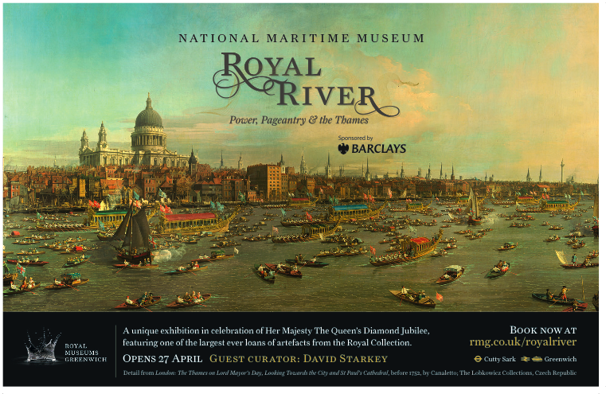

Activity 1
This half-page press advertisement appeared in the Times to promote Royal River: Power, Pageantry & the Thames in 2012.

Analyze the advertisement by answering the questions below. Give reasons for each answer.

What do you think your experience will be like at the exhibition?

Who do you think is the target audience?

Is this a successful promotion?

What are the criteria for a successful advert?

[Captures attention in a short time]
[Sums up a message or story in the clearest way possible]
[Successfully communicates to the right audience]
[Clear themes, eg, historical, prestige, power]
[Good use of text, colour and layout]

Activity 2

Imagine you’re in the Marketing team at the National Maritime Museum and you’ve been asked to write a brief for new press ad that will attract a younger audience to the Museum.

Your target is 16-24 year olds. You can choose any existing product or service at the Museum to promote (eg, you might choose one of the existing galleries or exhibitions).

Write a brief for your advertising agency.

Consider:
- What product or service are you going to promote?
- What aspects do you think most appeal to your target audience?
- What is the most compelling message for your audience?
- What information does your ad need to get across?
- What imagery would you recommend?
- Where would you recommend placing your ad?

