A visual guide to the Royal Observatory School Visits
We look forward to seeing you on a visit soon.
If you have questions in advance contact us on ROGEducation@rmg.co.uk

If you’re looking for activities to do before or after your visit we have free learning resources available here: https://www.rmg.co.uk/schools-communities/all-astronomy-science-resources
If you want an activity to do during a self-guided visit to our historic site, we have trails available here: https://www.rmg.co.uk/schools-communities/visit-guides-activities

My Visit to the Observatory
I will go through the park to get to the Observatory.
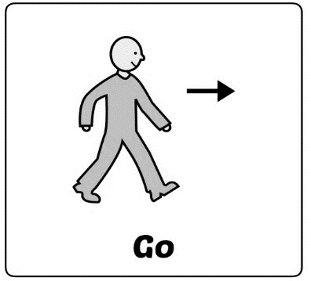
Outside of the Observatory looks like this:
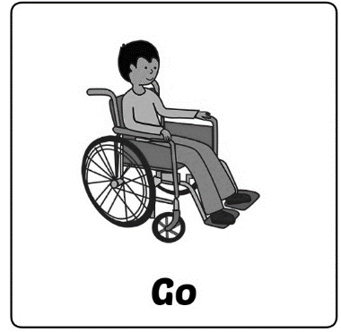
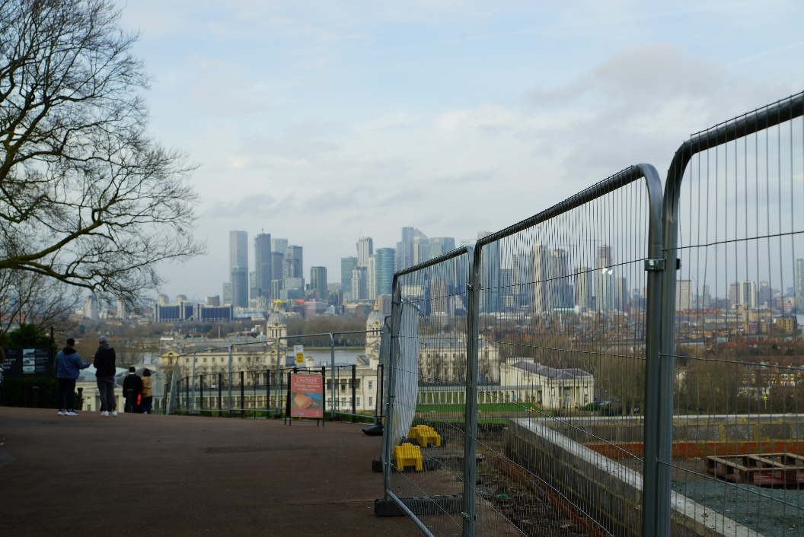

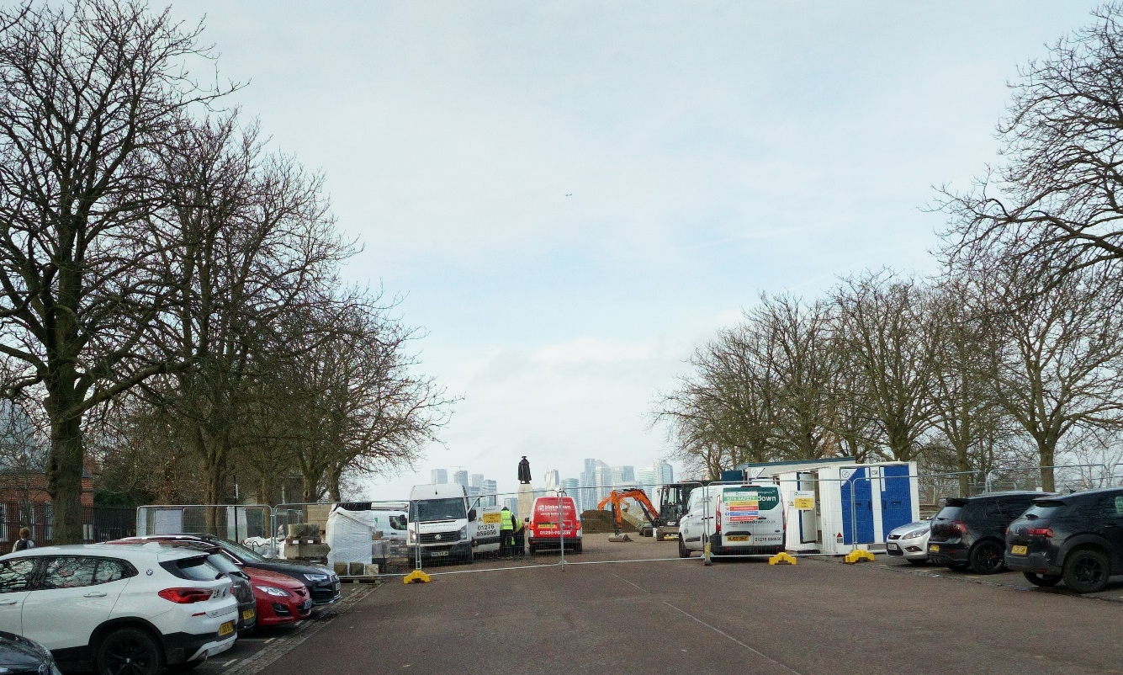

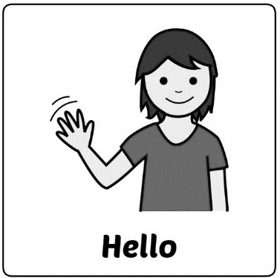

I will go along this path and through this gate to get into the Observatory.
The people in blue uniforms work here. They are happy to help!
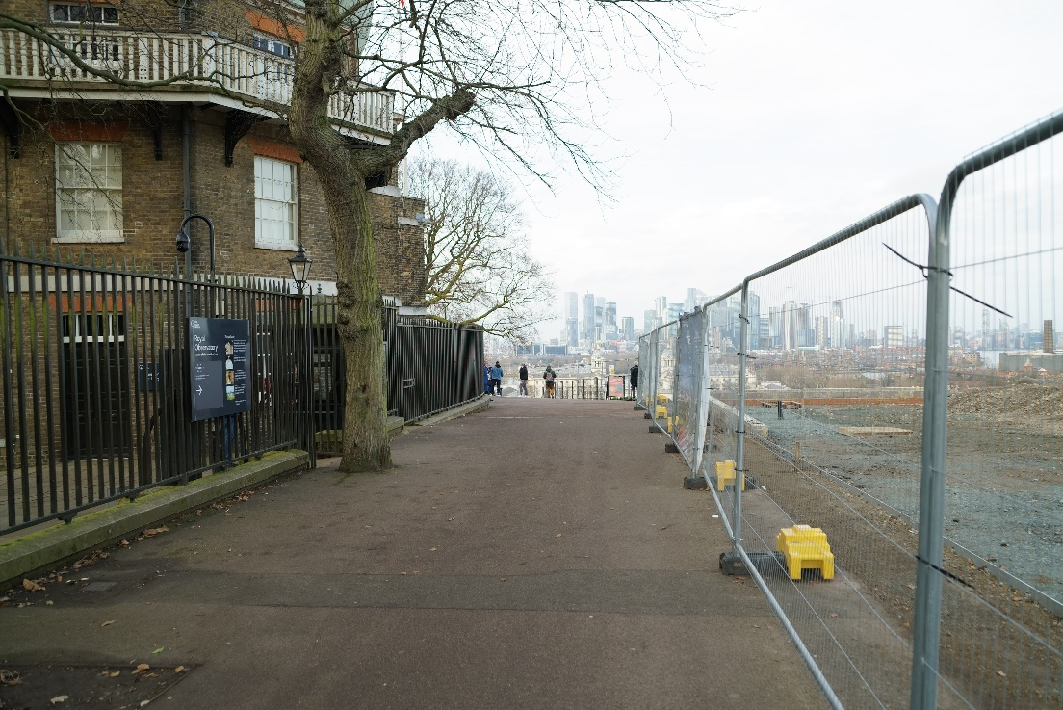

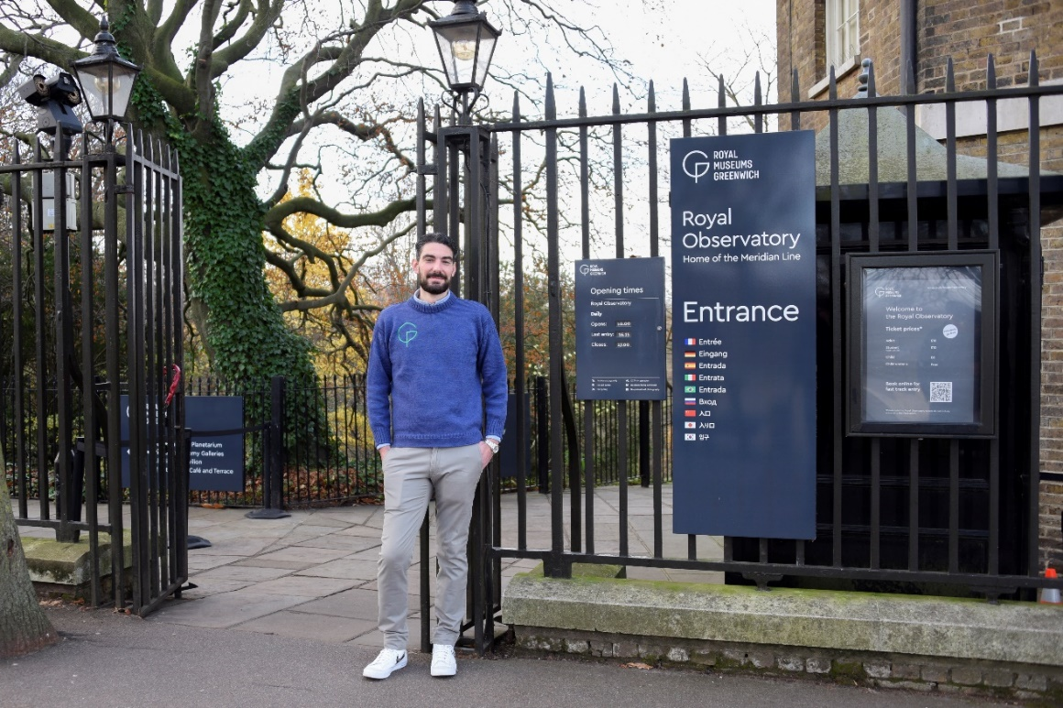

I will go to a building made of red and yellow brick.

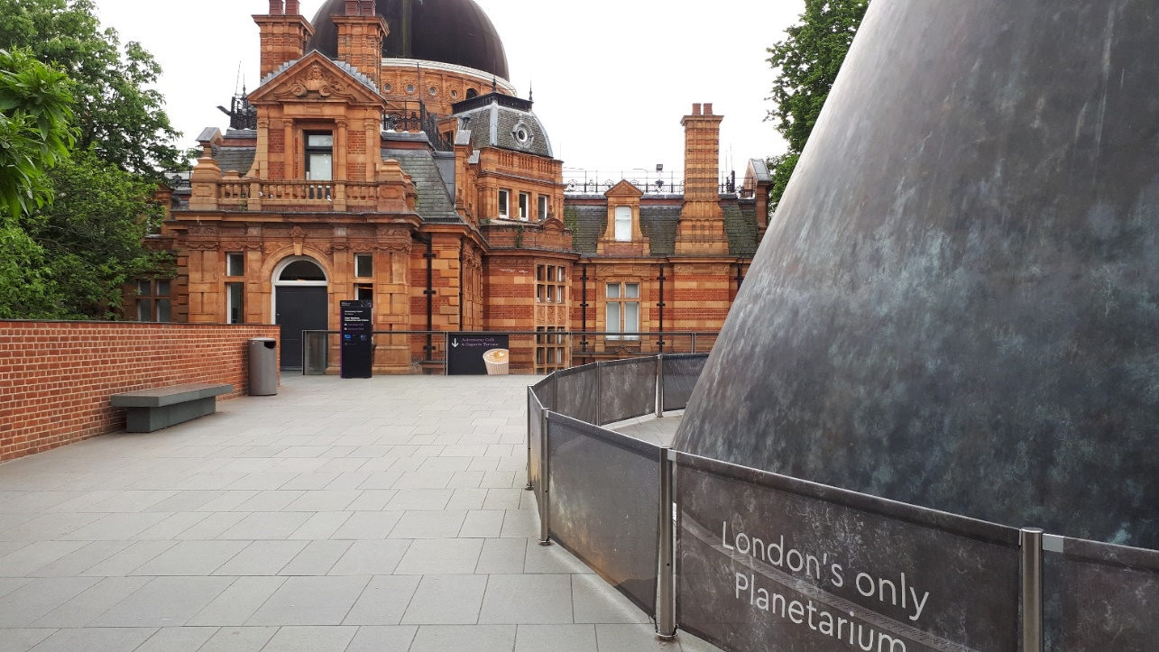

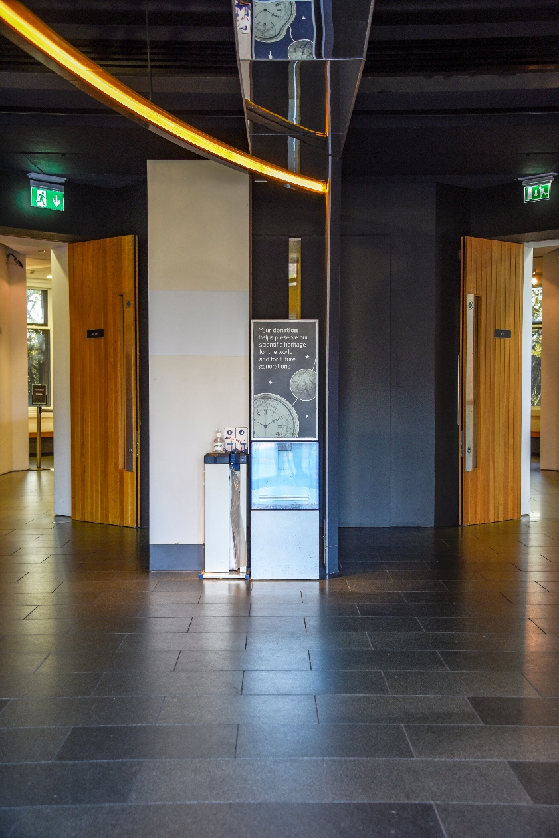

First I go into this entrance space.

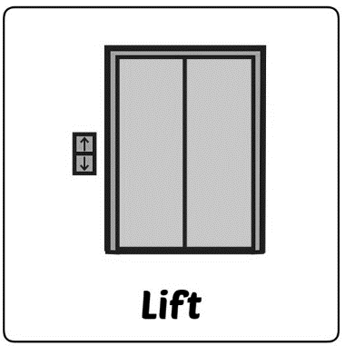
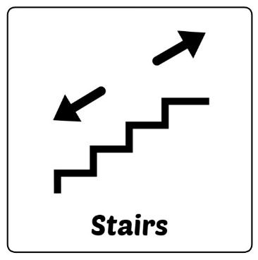
When I go through the entrance space I enter this area.
There is a lift and also a spiral staircase.

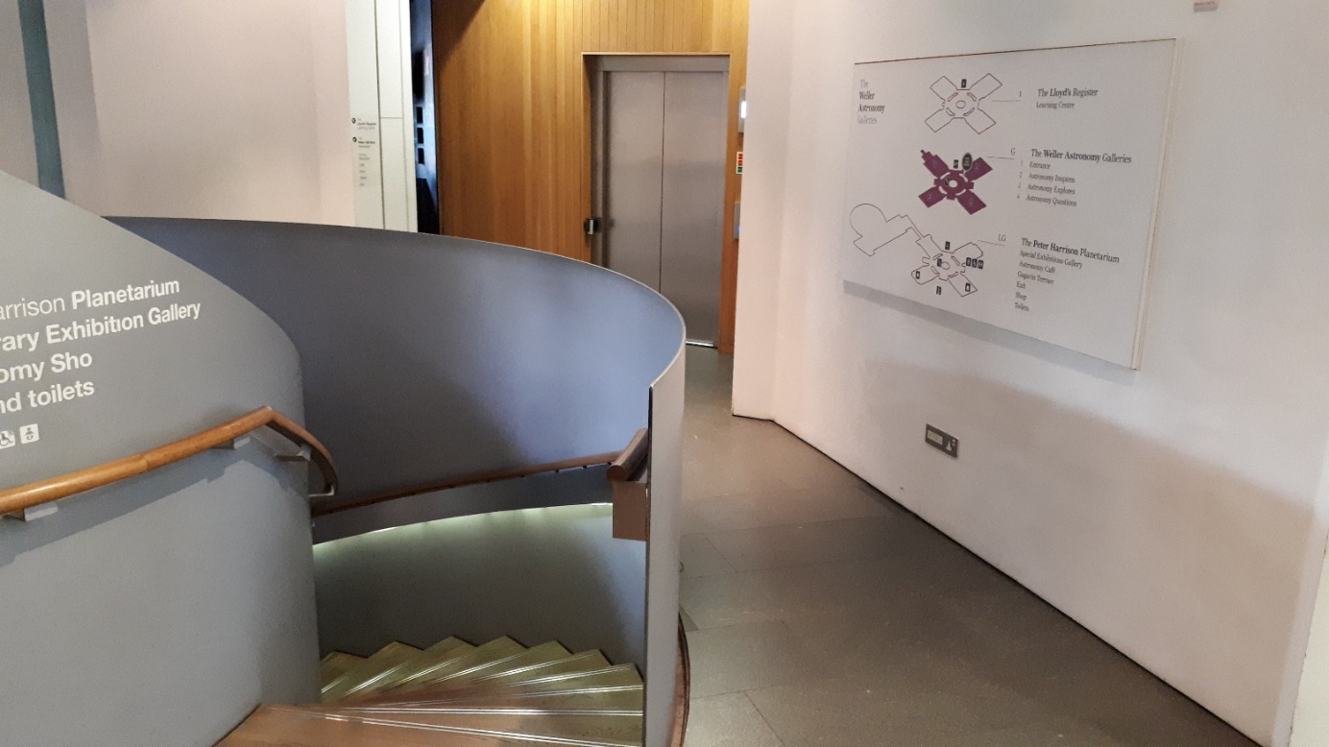

Toilets
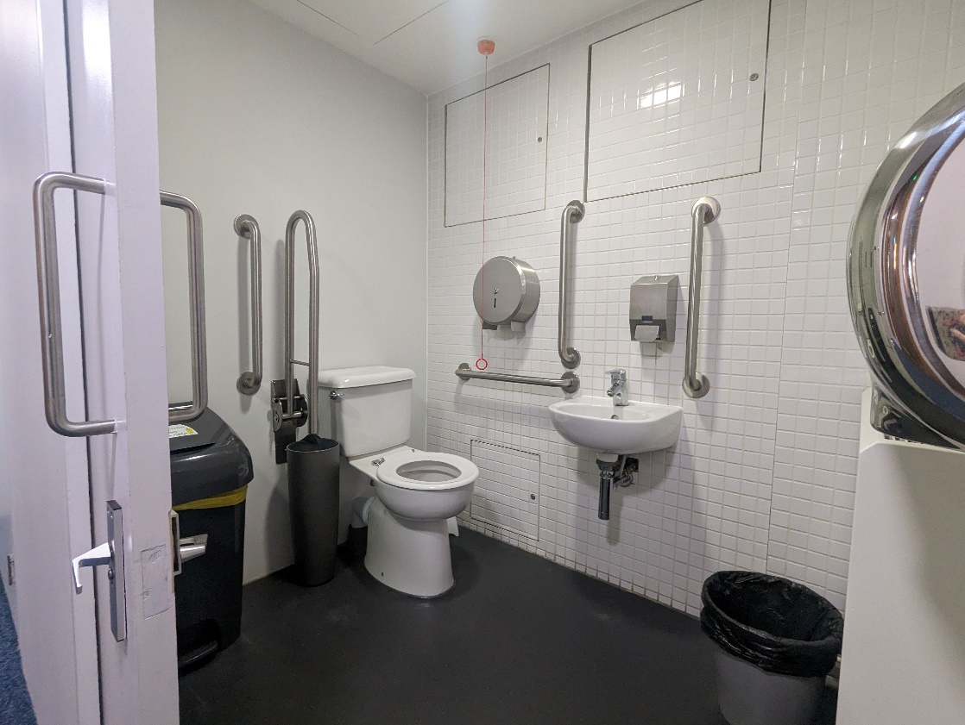
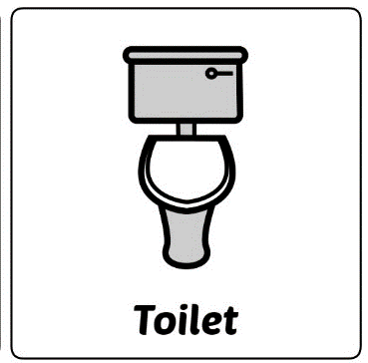

If I want to use the toilet I can go to floor -1 or floor 1.

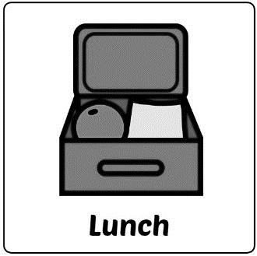

There is a café on floor -1
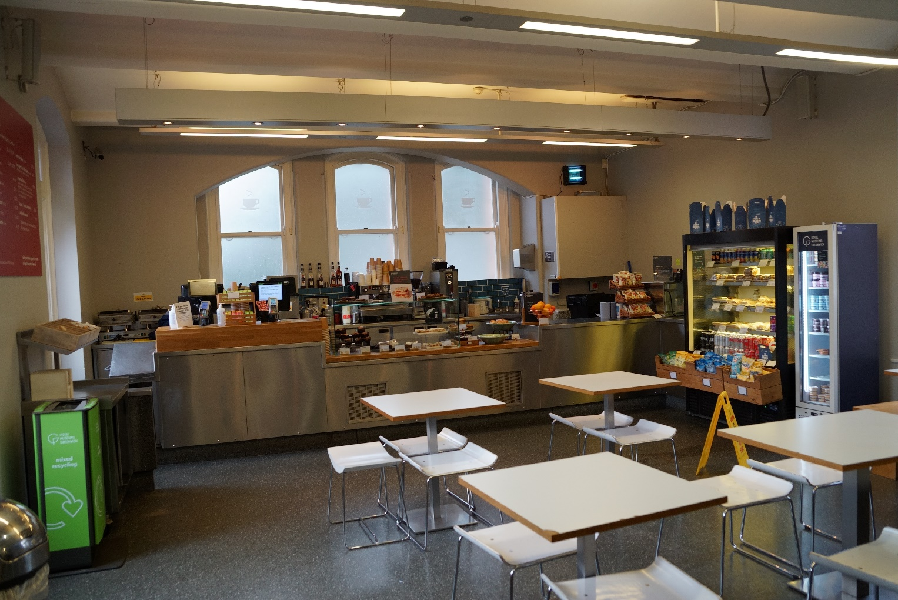

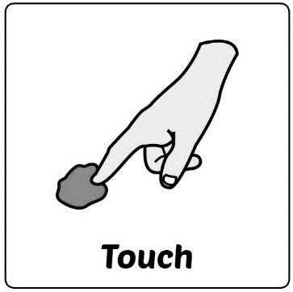
If I go to the planetarium I go to floor –1.
At the bottom of the stairs is a meteorite. I can touch this if I want to!

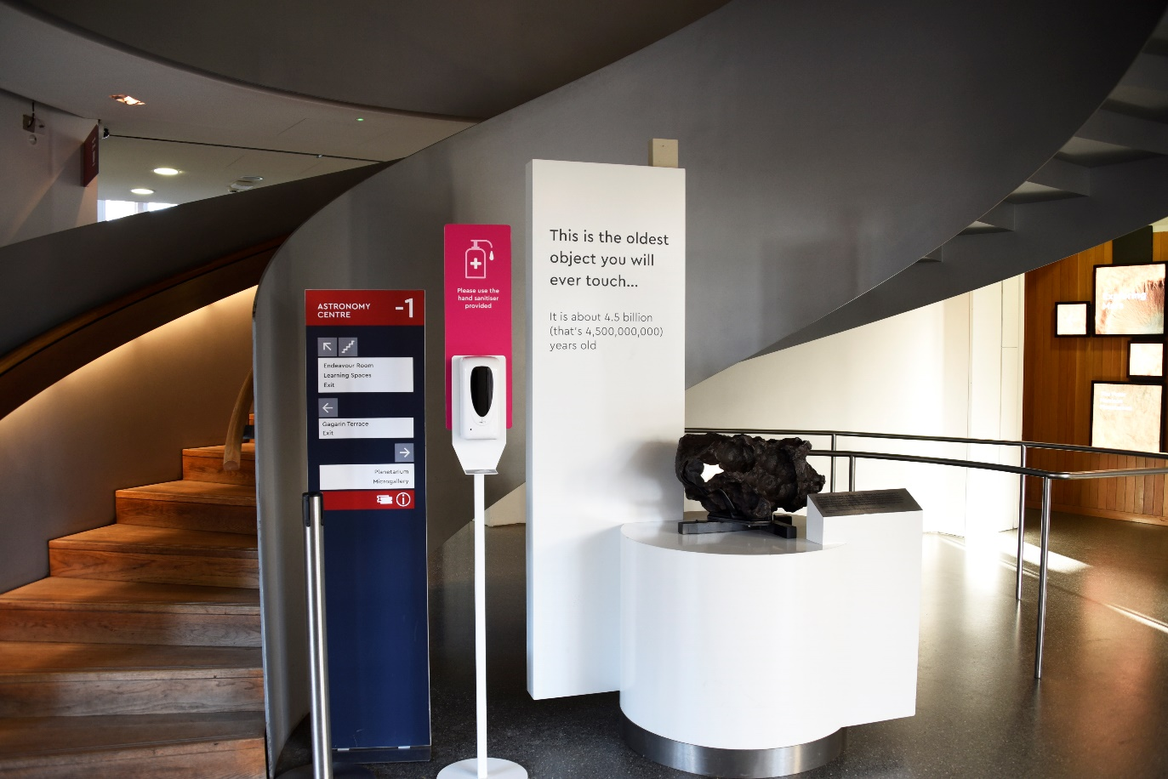

I go through the gallery to get to the planetarium. It has photos and videos playing.
This space is darker but the pictures are brightly lit.
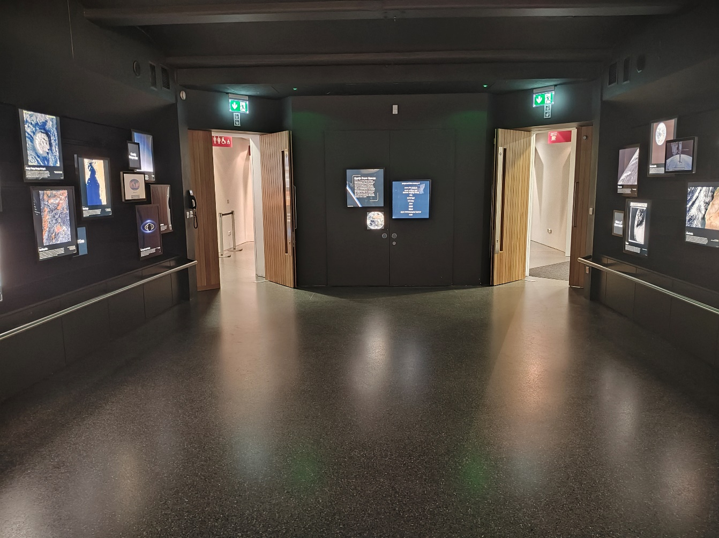
If I don’t like the dark I can tell my teacher.

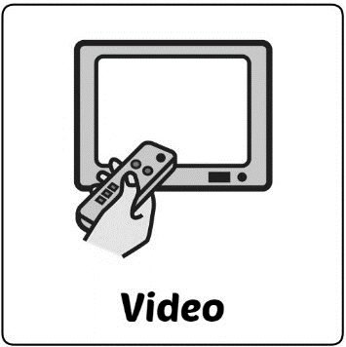
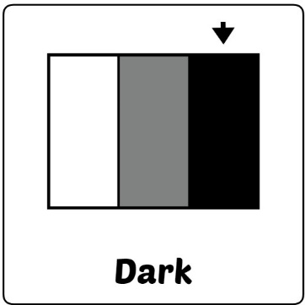

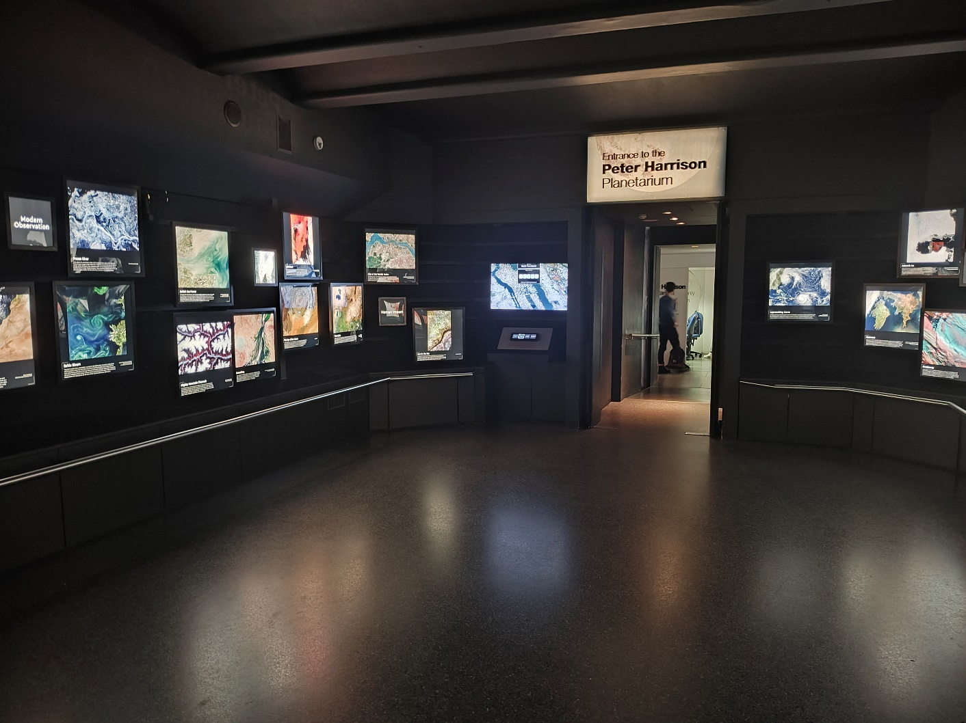
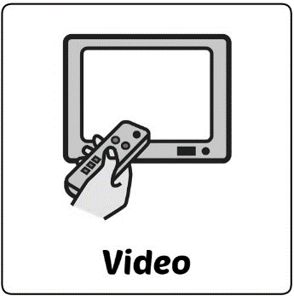

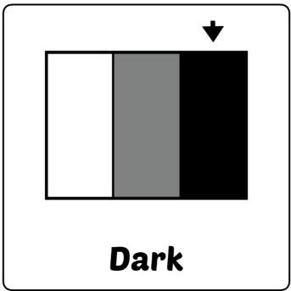

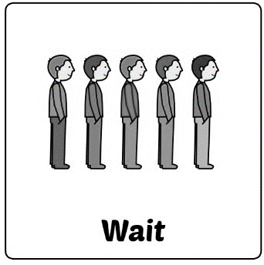
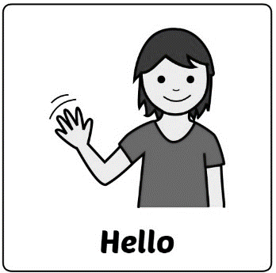

Before I go to the planetarium I wait in the planetarium foyer.
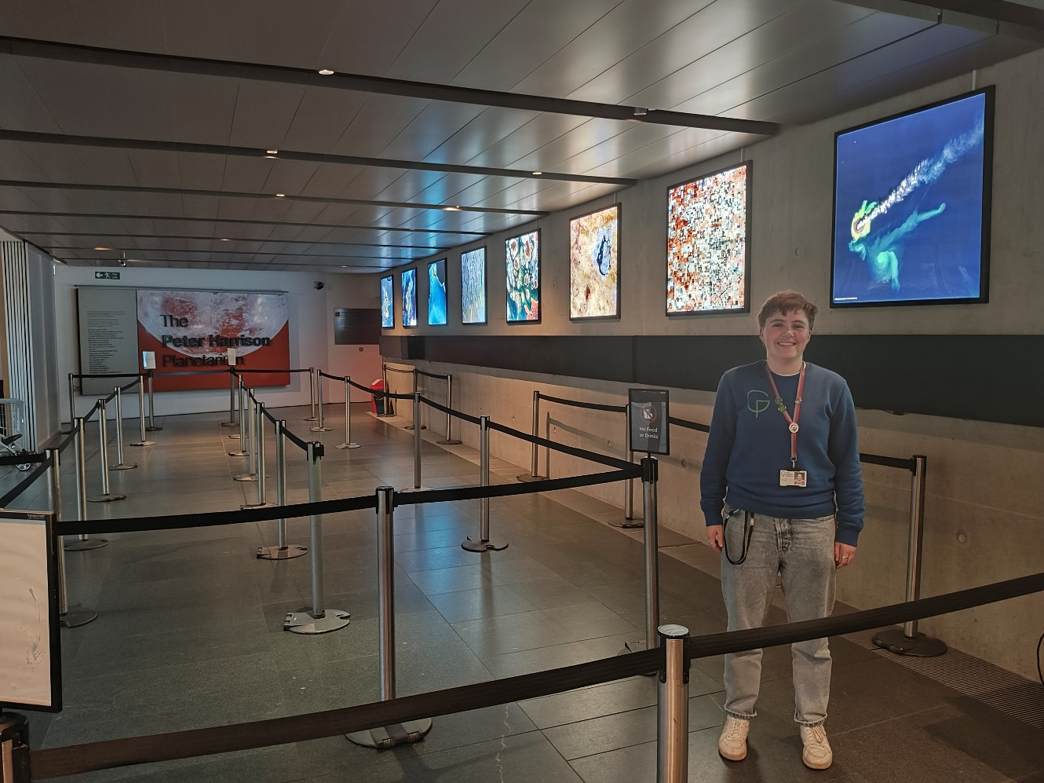
I will meet a staff member in a blue uniform who will tell me when I can go into the planetarium.

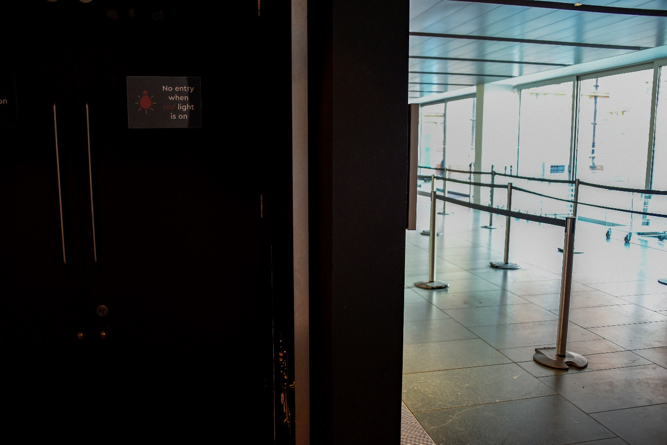
I go through a set of double doors to enter the planetarium.
It’s darker in here.
If I don’t like the dark I can tell my teacher.
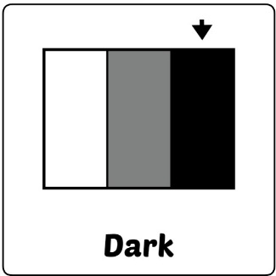

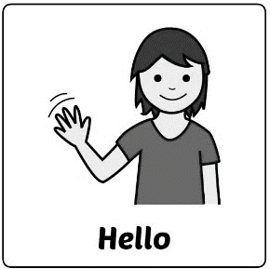

In the planetarium I will meet a friendly astronomer, who works here.

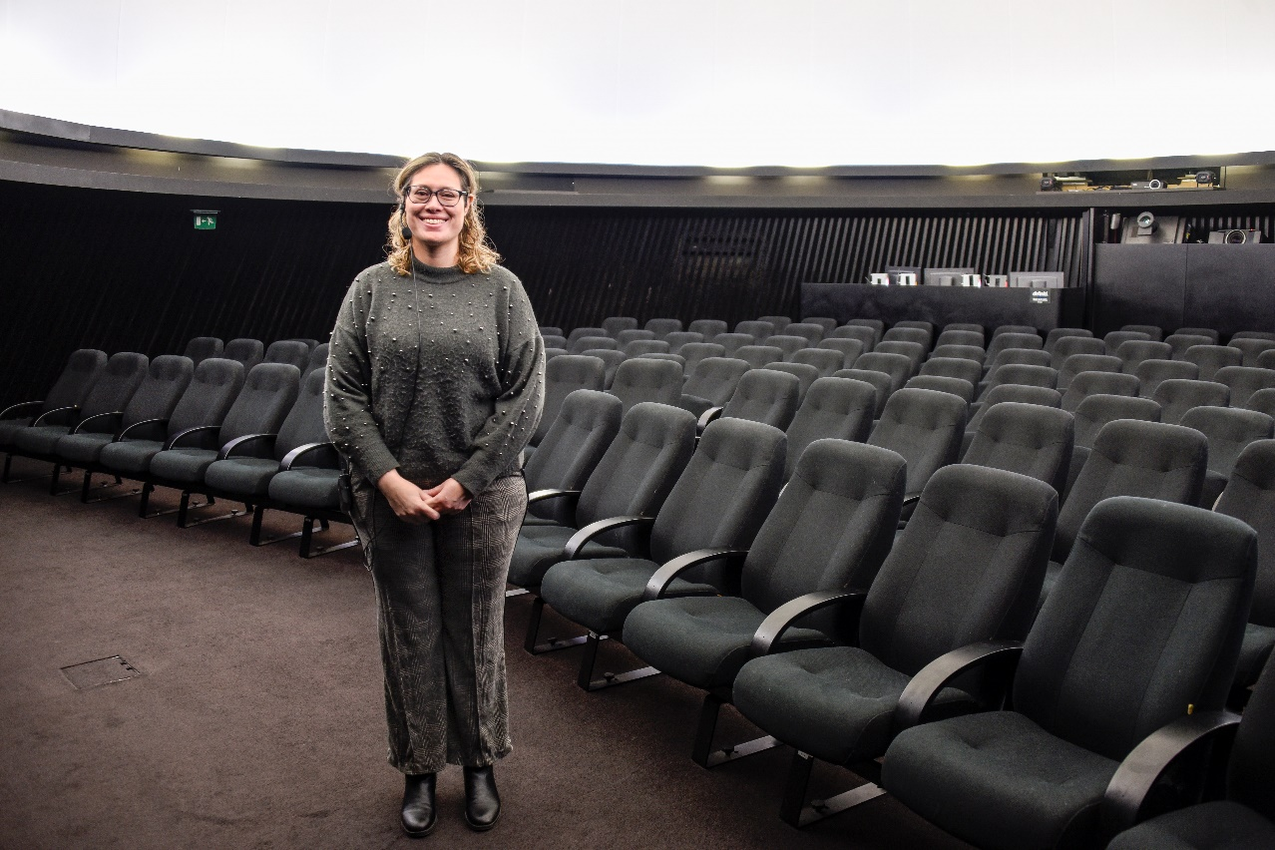

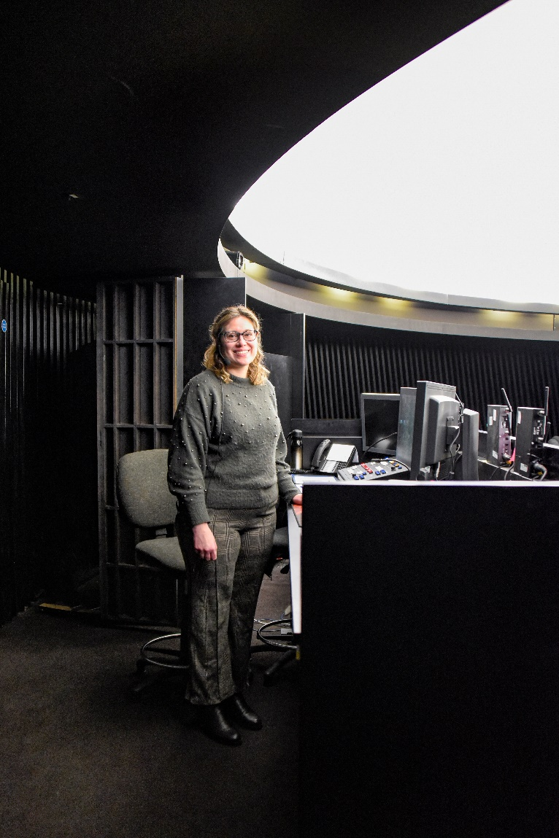

During the show I’ll sit in my seat.

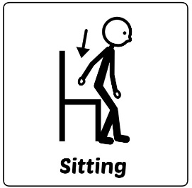

The astronomer will be at a desk at the back.

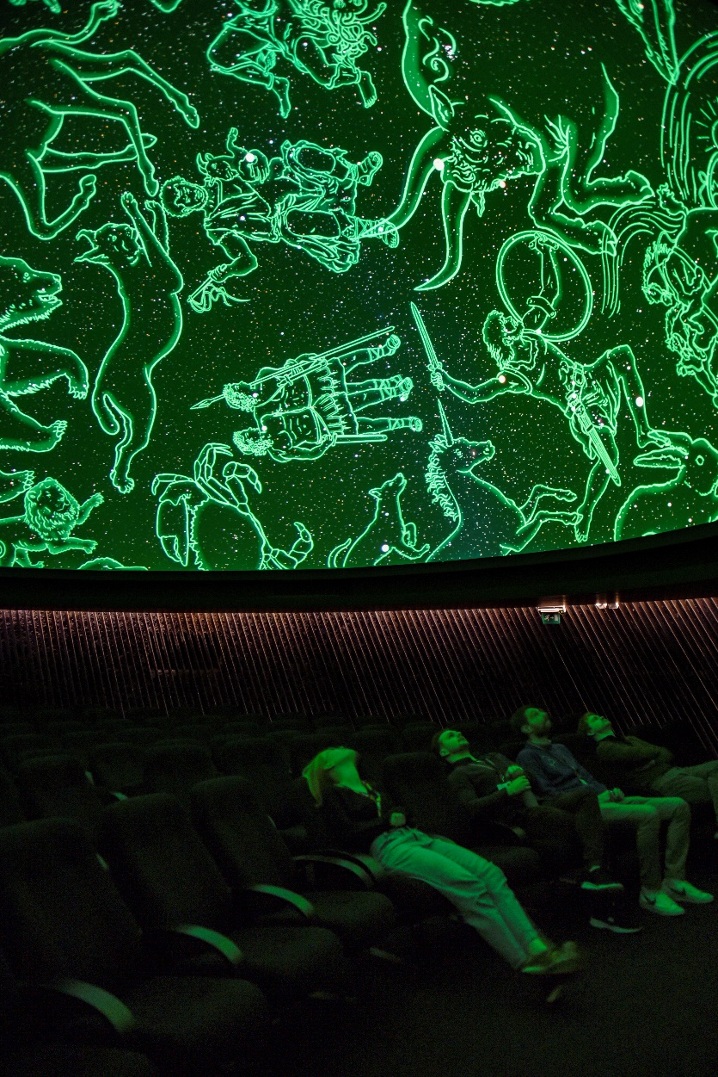
When I’m ready the lights will slowly turn off and the show will start.
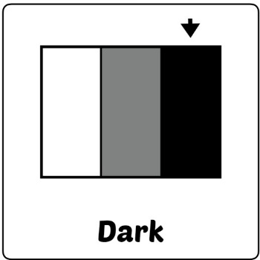
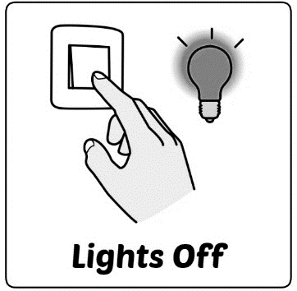

I’ll see the night sky, or beautiful pictures of different things in space on the ceiling.
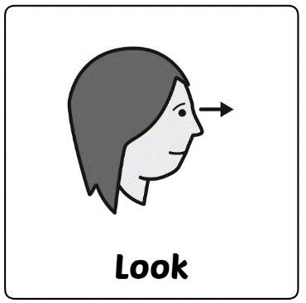
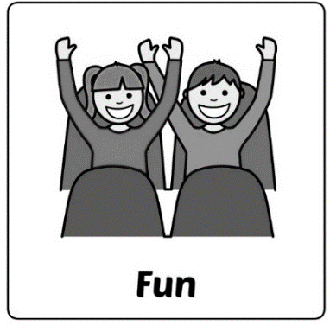

The astronomer will talk about what we’re seeing during the show.
If I don’t like it I can tell my teacher so we can leave.
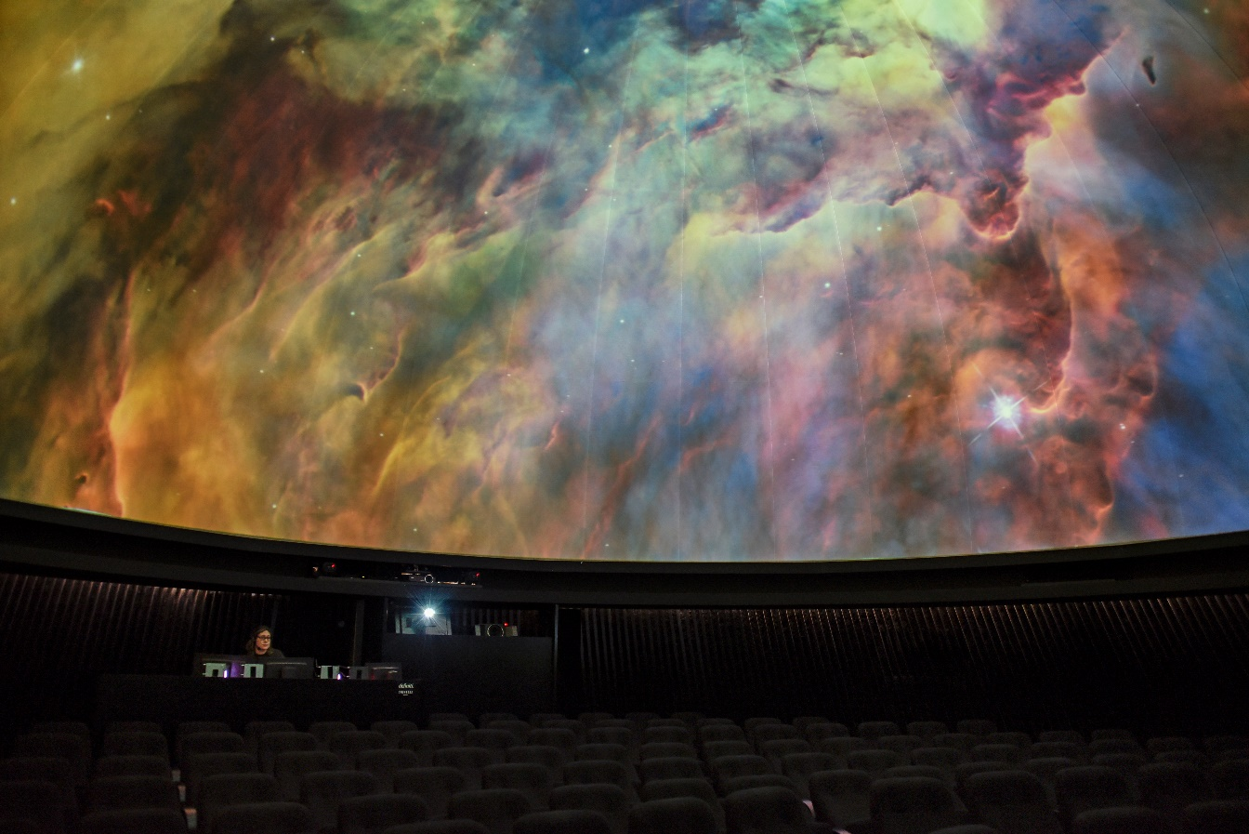

When it’s time to eat my lunch I’ll go up to the first floor to the lunch room.

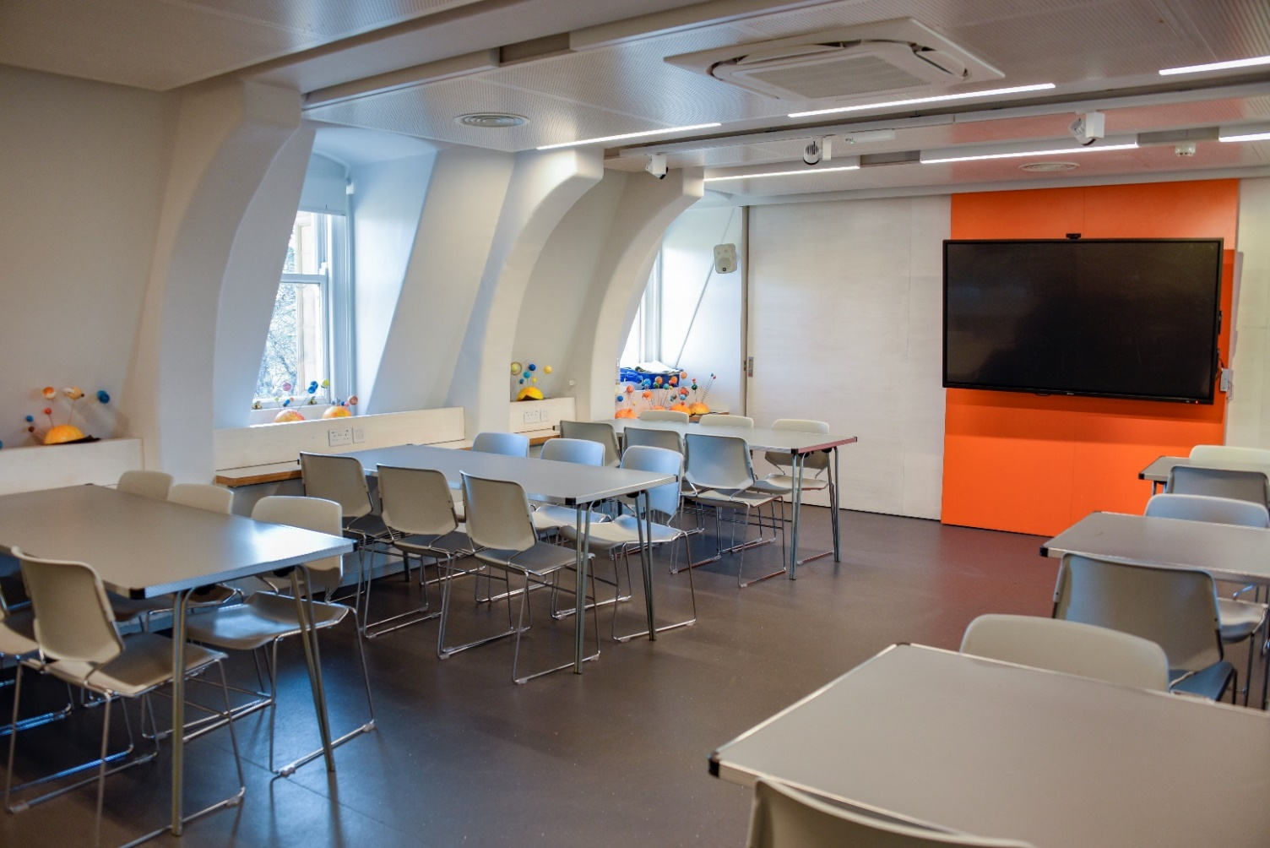

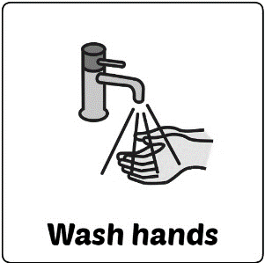

In the lunch room there is also a sink so I can wash my hands.

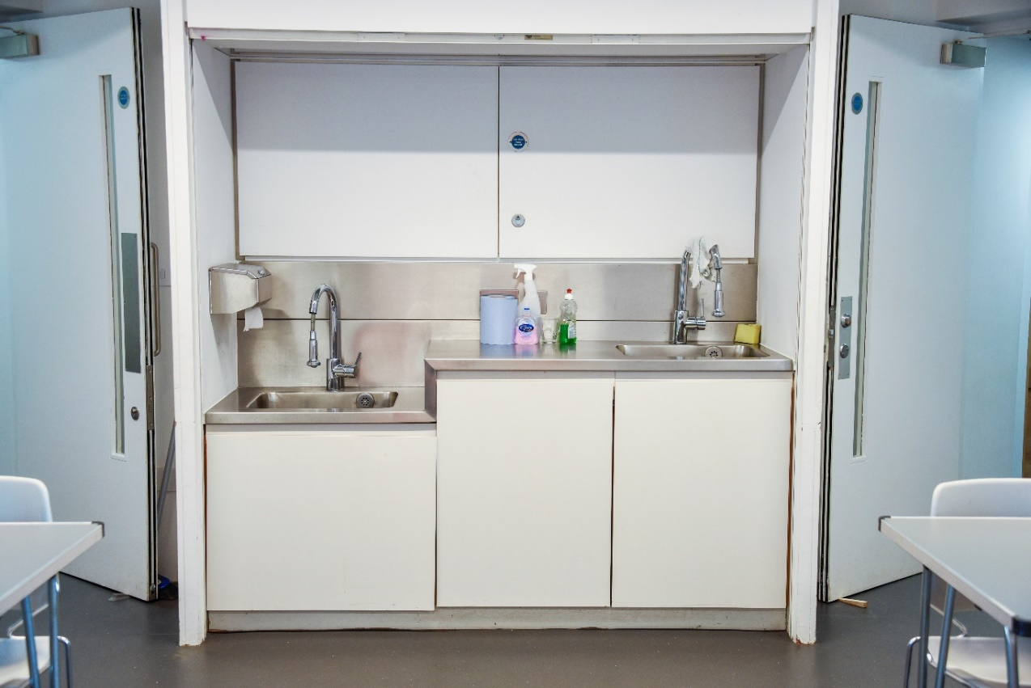

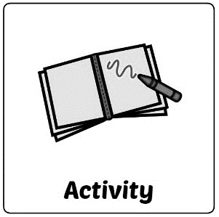
When it’s time for the workshop I go to the learning space. Here I’ll meet another friendly astronomer who will show me different activities about planets.
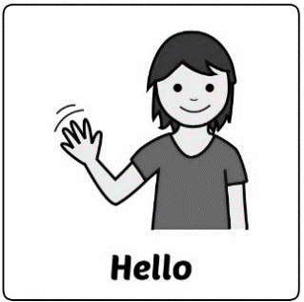

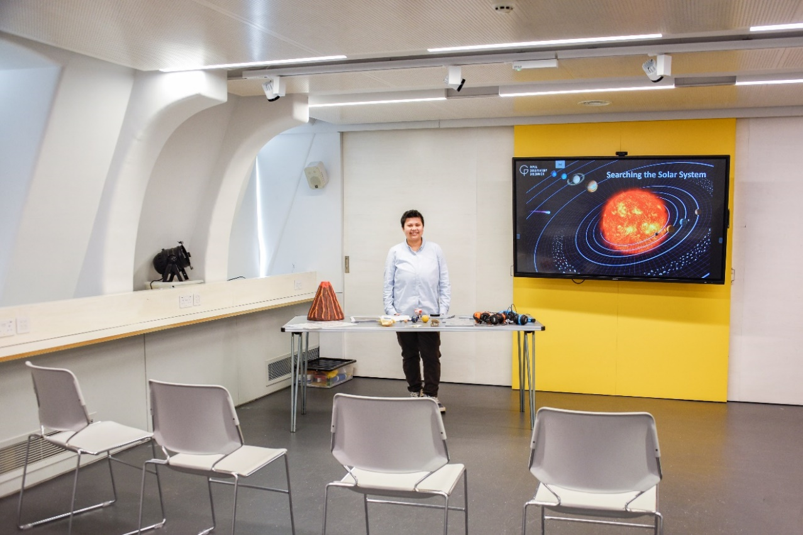

I can also ask questions about space if I want to.
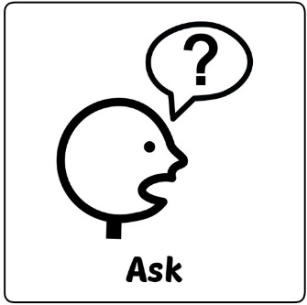

If there are activities I don’t want to do that’s okay.

I will also do an activity in another learning space. This includes watching a video.
If there are activities I don’t want to do that’s okay.

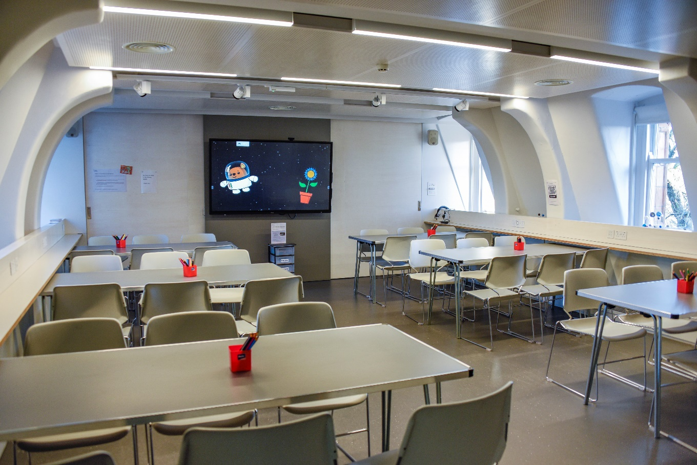
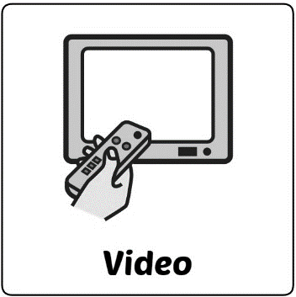

Quiet Space
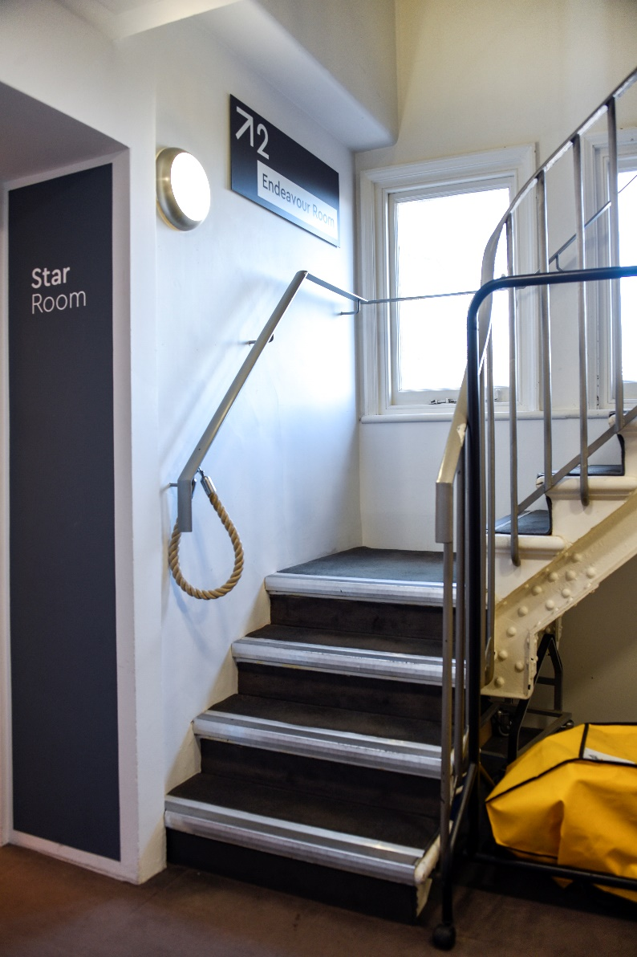

If I want to take a break, I can tell my teacher and go to the quiet space.

There is a lift or stairs.

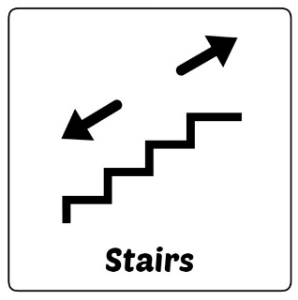
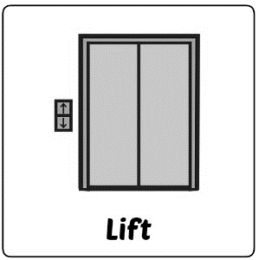

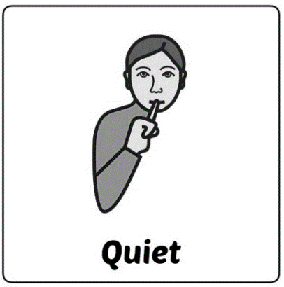

In this room it is quiet.

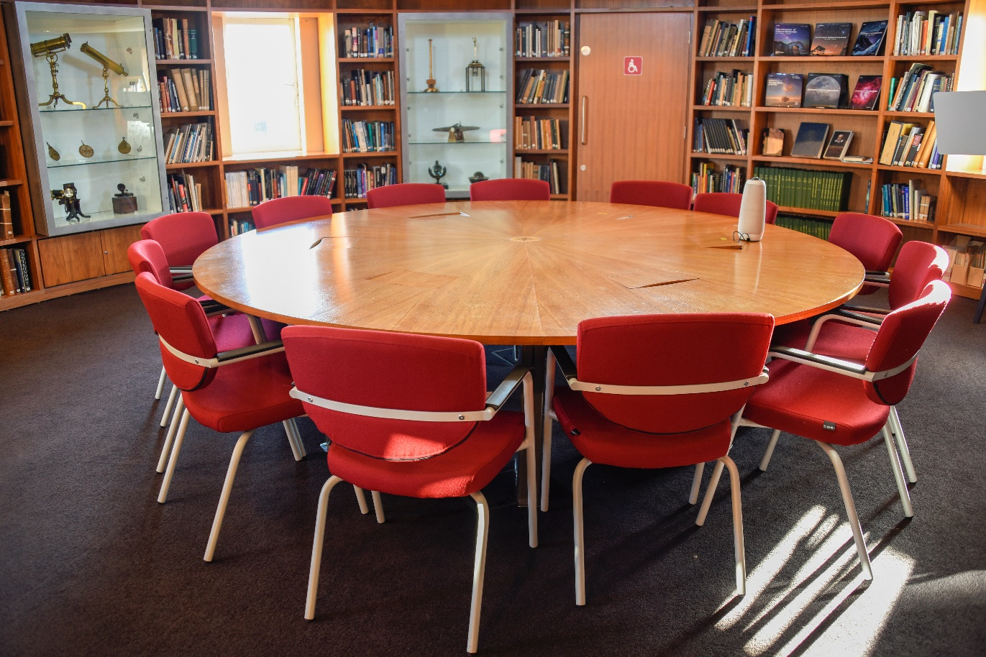

Exploring the historic site

When it is time to visit the museum I leave the astronomy centre and go past this small building.
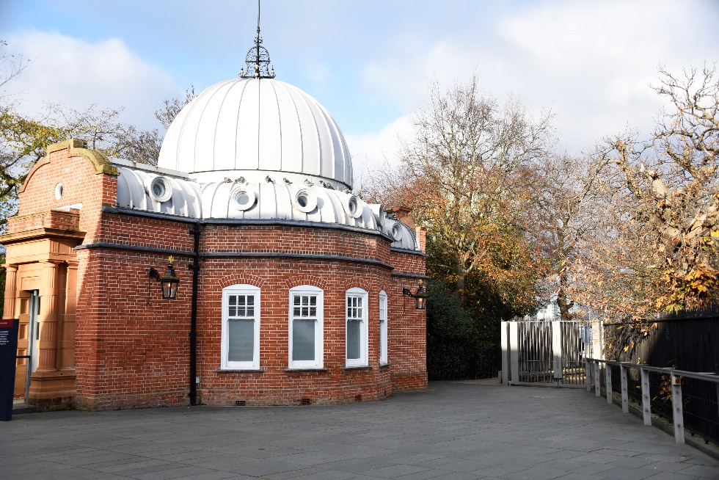
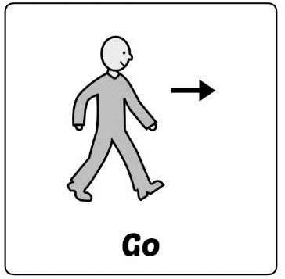

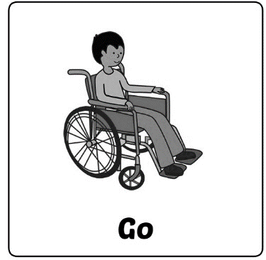

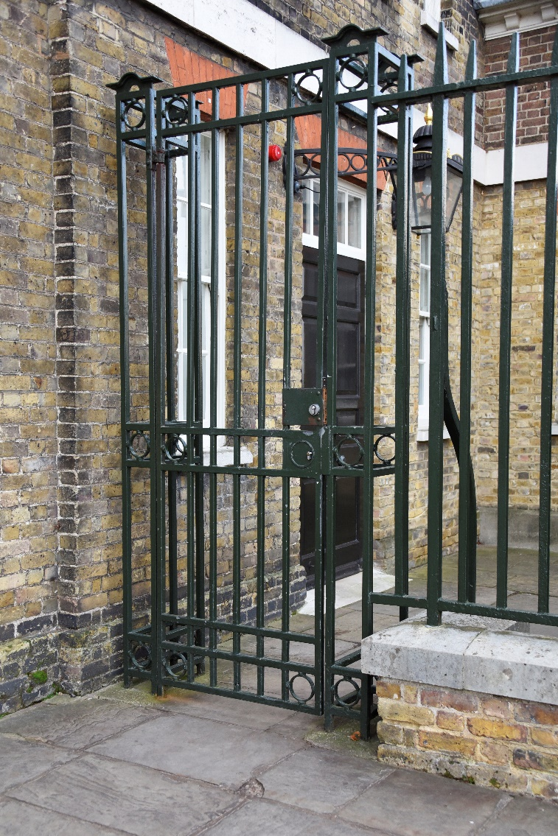

Somebody who works here in a blue uniform will let me through this gate.

In this area there are lots of other people and it might be busy.

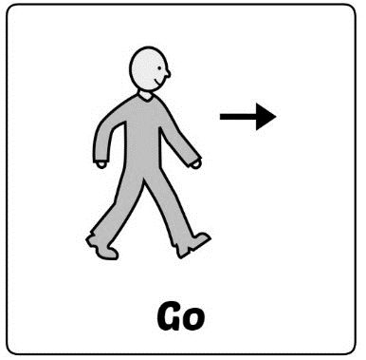
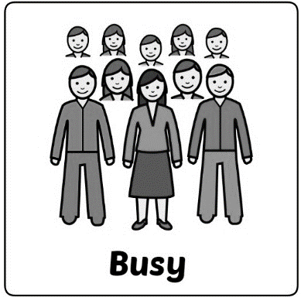

I can explore this courtyard and go along the prime meridian.

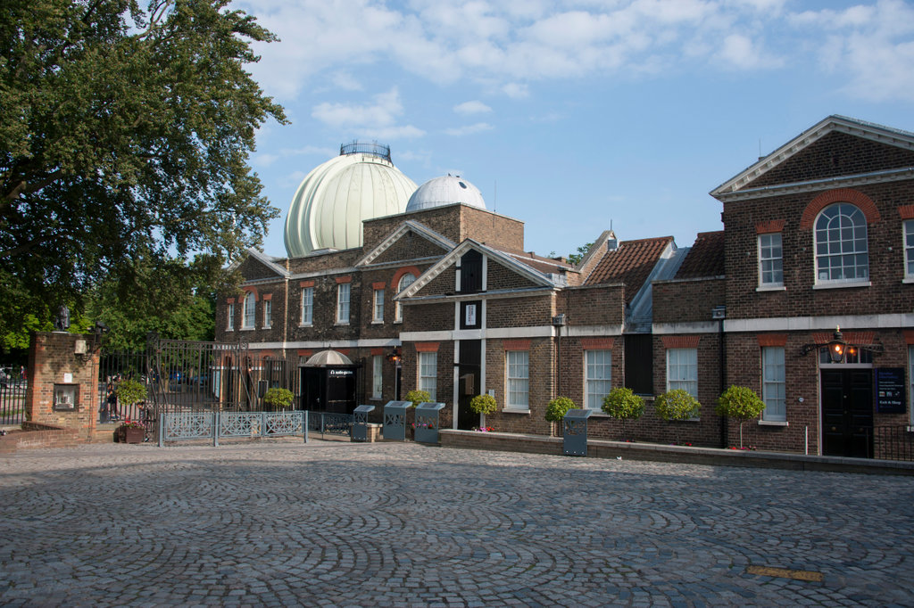

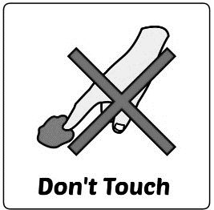
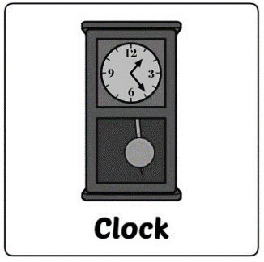
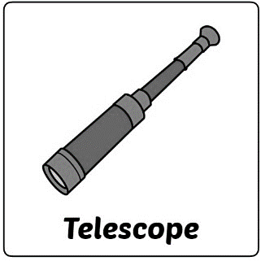

I can go into the museum galleries and look at the clocks and telescopes.

These are very old and so I can’t touch them.

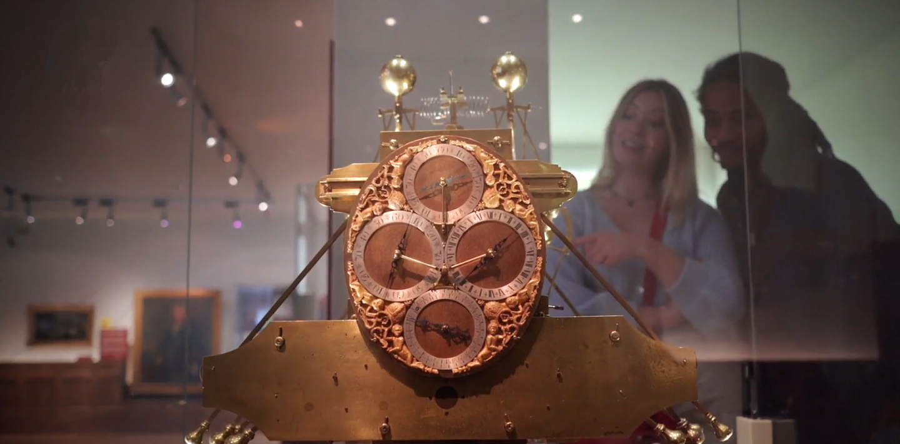

Great Equatorial Telescope
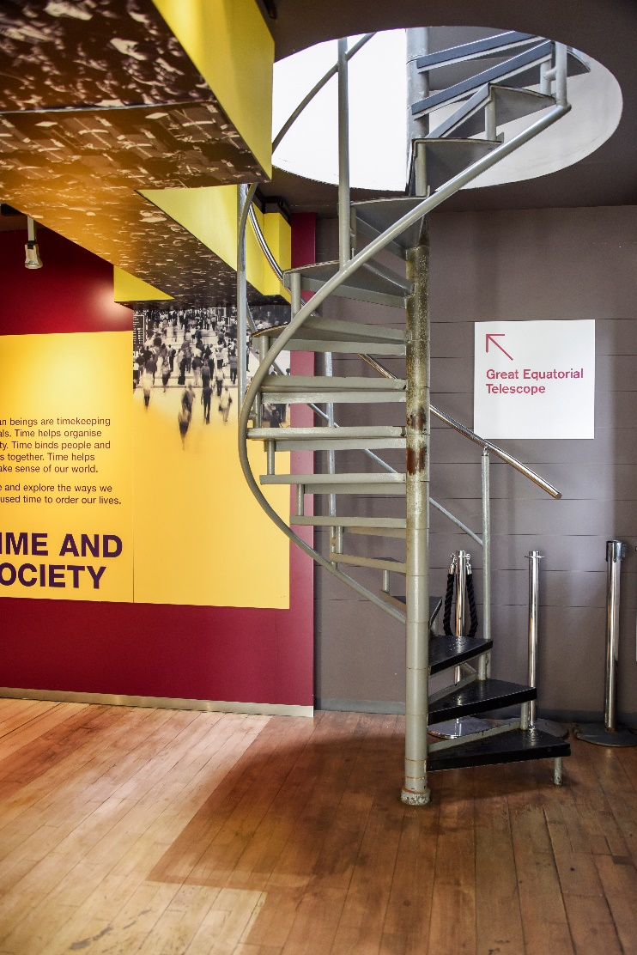

When I visit the Great Equatorial Telescope first I will climb a metal spiral staircase.

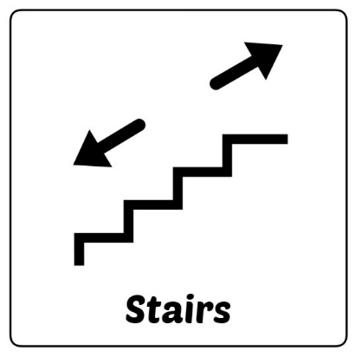

Then I go along here. I can see a great view from here!
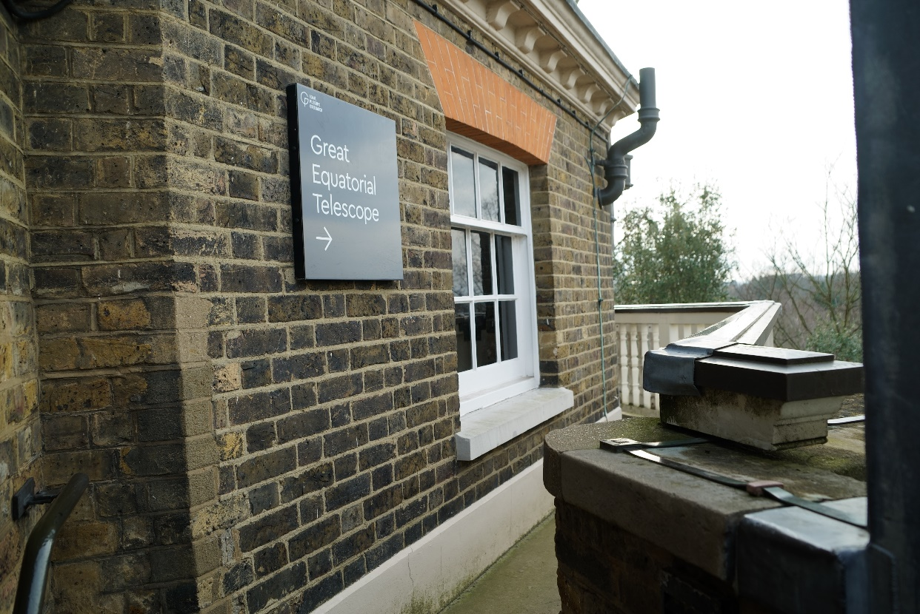

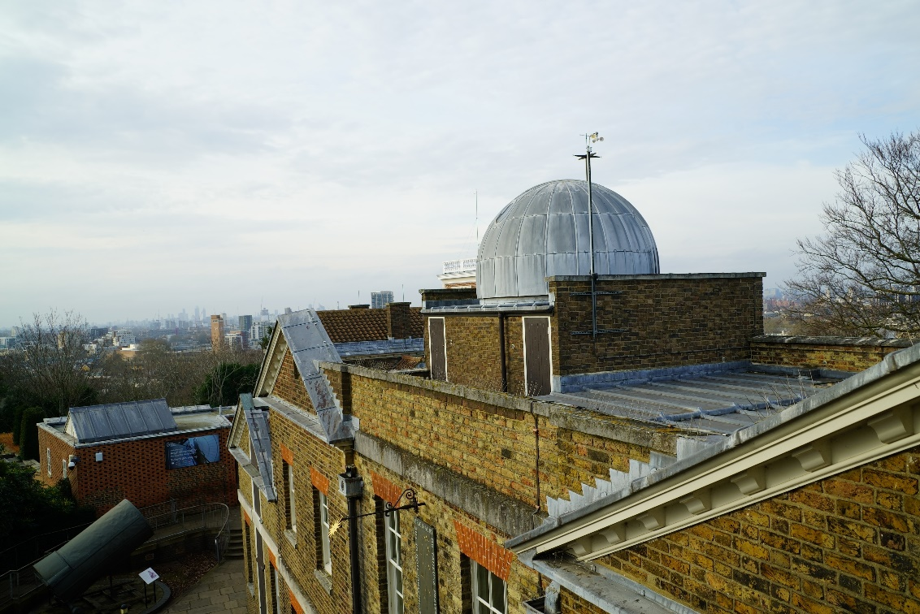

Inside the building I can see the Great Equatorial Telescope.
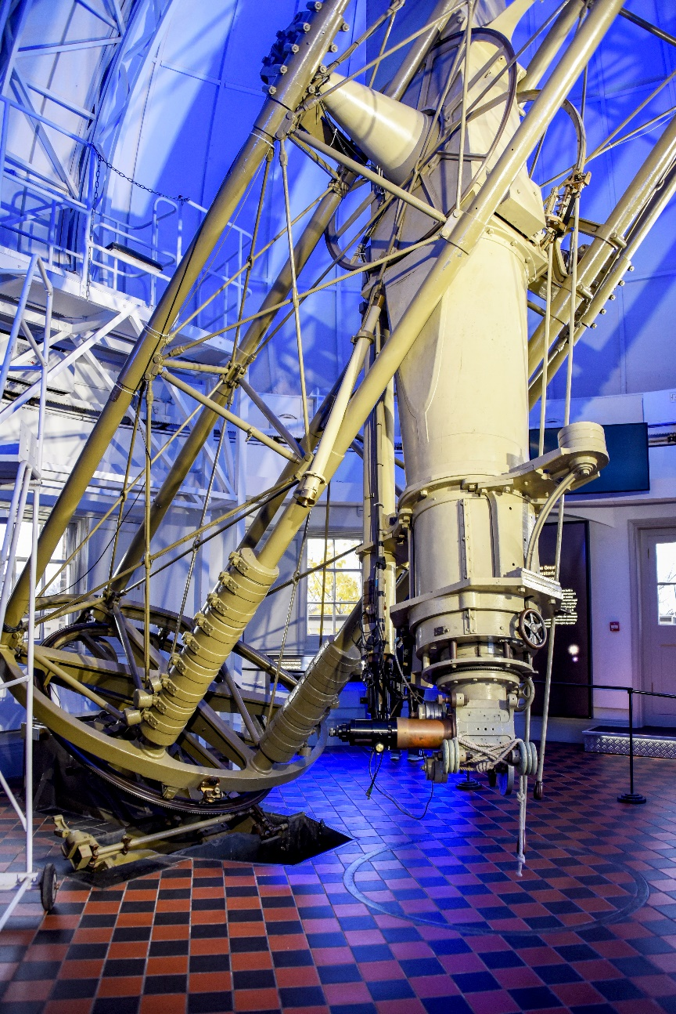
In this room there is a metal barrier around the telescope and I have to stay behind while I look.

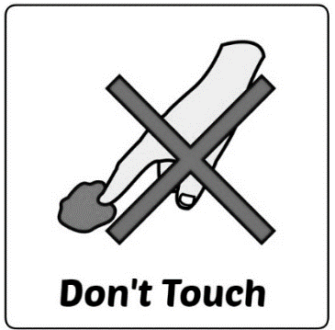

Sometimes the ceiling is lit up with different coloured lights.

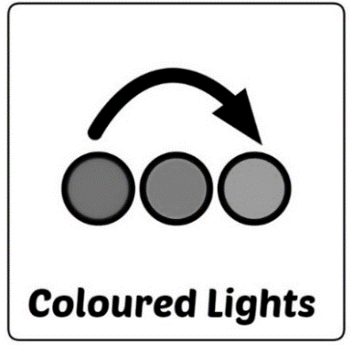

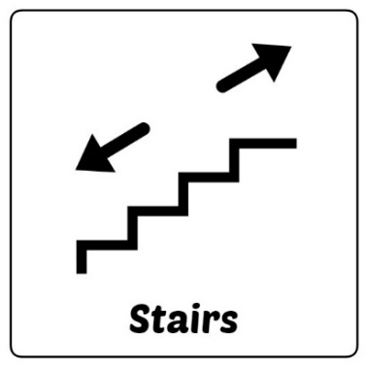

When I want to leave I go down another spiral staircase.

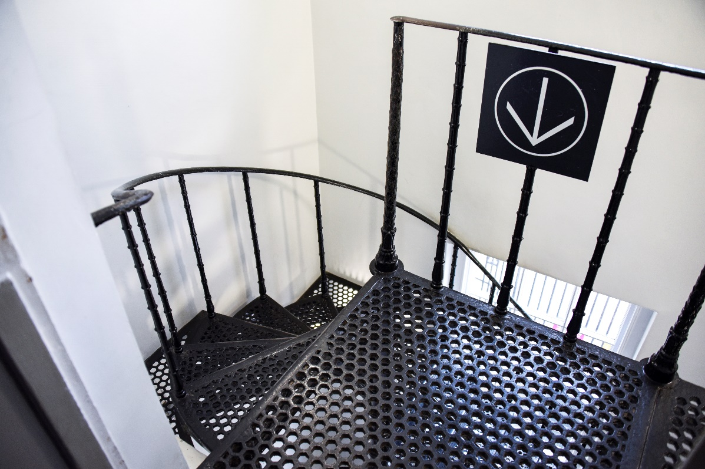

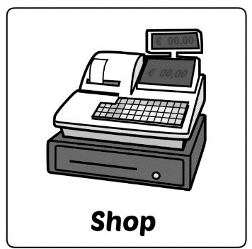

I might visit the shop if I have some money I want to spend.

