The National Maritime Museum Visual Guide
This guide has been created to help visitors navigate the museum.
For a more detailed guide, please see our Access Statement. You can find this on our website.
You can use this guide to help you choose what you would like to see and do at the National Maritime Museum.
For more details on quiet, noisy, or smelly areas please see our Sensory maps. You can find these on our website.
You can download a floorplan of the museum on our website.

This is the National Maritime Museum.
There are lots of things to see and do at the museum.
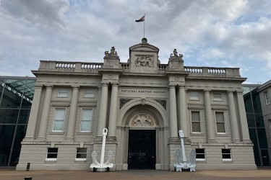
You can enter through the Romney Road Entrance between these anchors.
You can also enter through the Parkside Entrance.
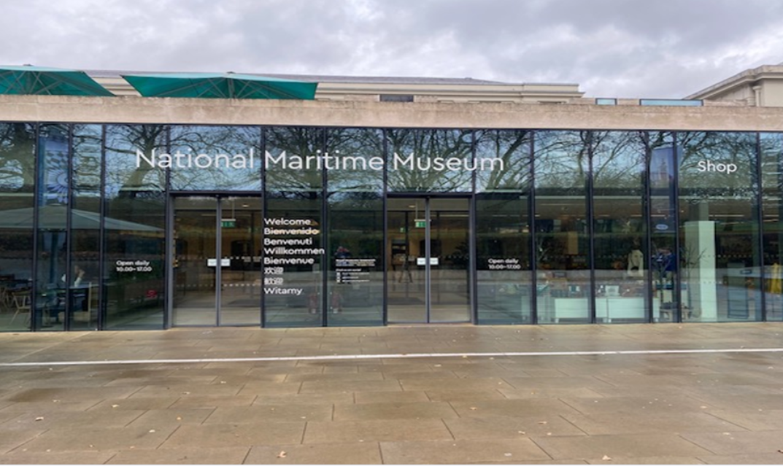
This is the Parkside Entrance.

The museum is open every day apart from Christmas Eve, Christmas Day and Boxing Day (24, 25 and 26 December).
The museum opens at 10:00.
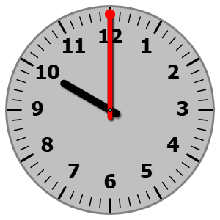
The museum closes at 17:00.

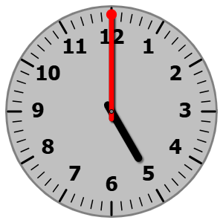

When you come into the museum, you will see staff.
You can ask them for help, suggestions, or directions if you would like.
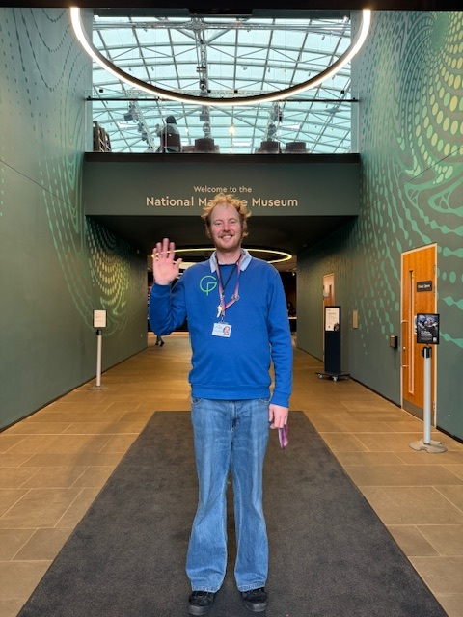

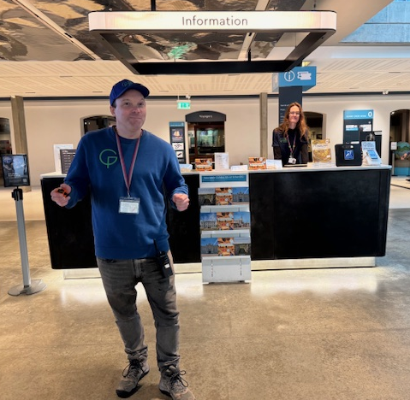
There are toilets near each entrance. 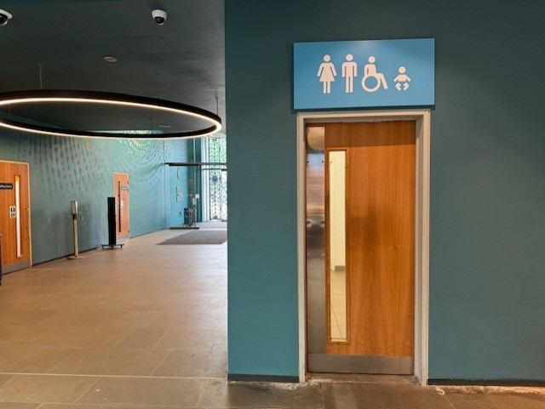
Above: This is the entrance to the Romney Road Entrance toilets. 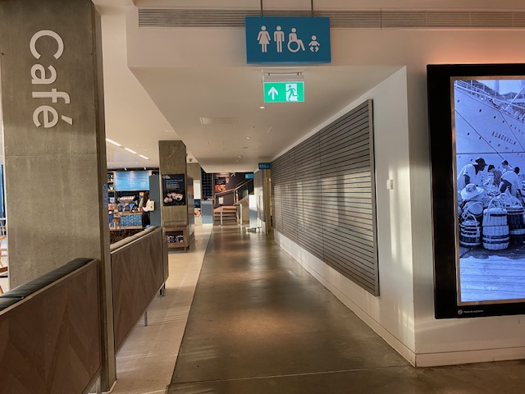
Above: This corridor, by the cafe, leads to the toilets by the Parkside Entrance.
There are other toilets around the museum.
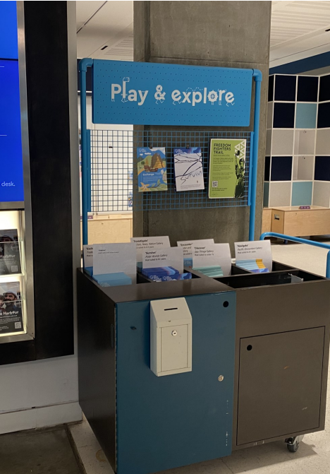
There is a Changing Places facility located near the Parkside Entrance. This is reserved for visitors with profound and multiple learning difficulties (PMLD) and other physical disabilities. Please ask a member of staff if you wish to access this room.
When you arrive, you can pick up a trail from the Play & Explore trolleys to help you explore the galleries. The trolleys are located near the entrances.

You can play in:
Ahoy! on Level 0 (the Ground Floor).
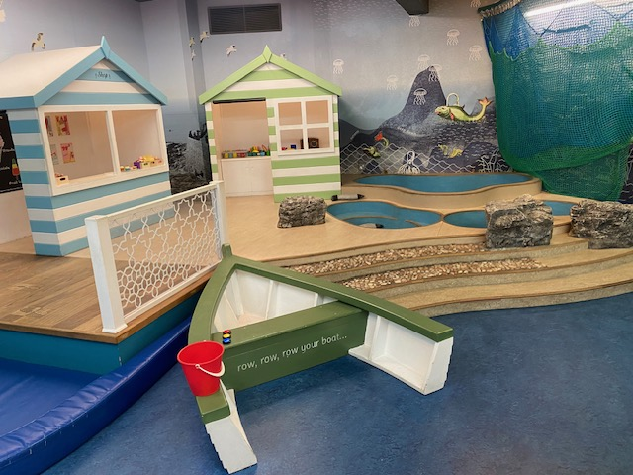
(This gallery is charged on weekends, bank holidays, and school holidays).
The Cove, in our grounds on the park side. 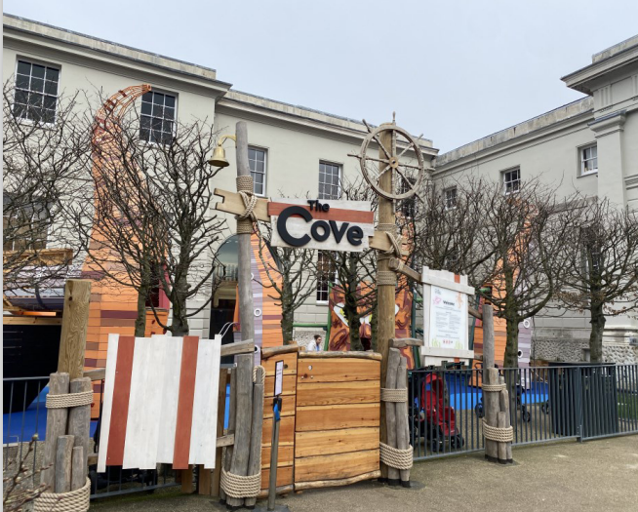

Ocean Map, on Level 1.
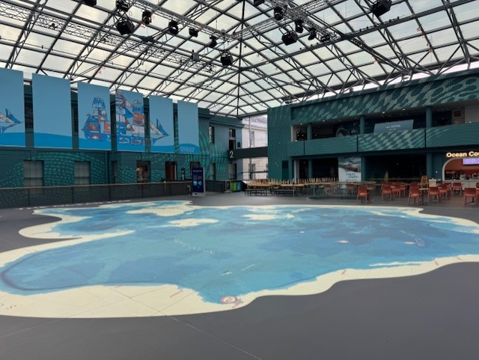

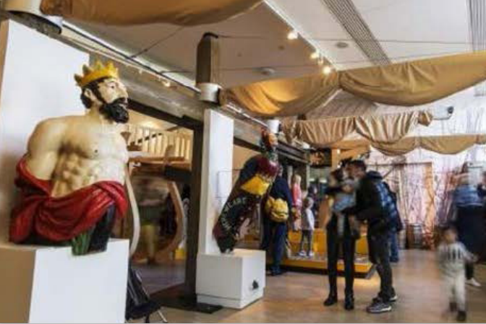
All Hands Children’s Gallery, on Level 2.

Small Hands, on Level 2.
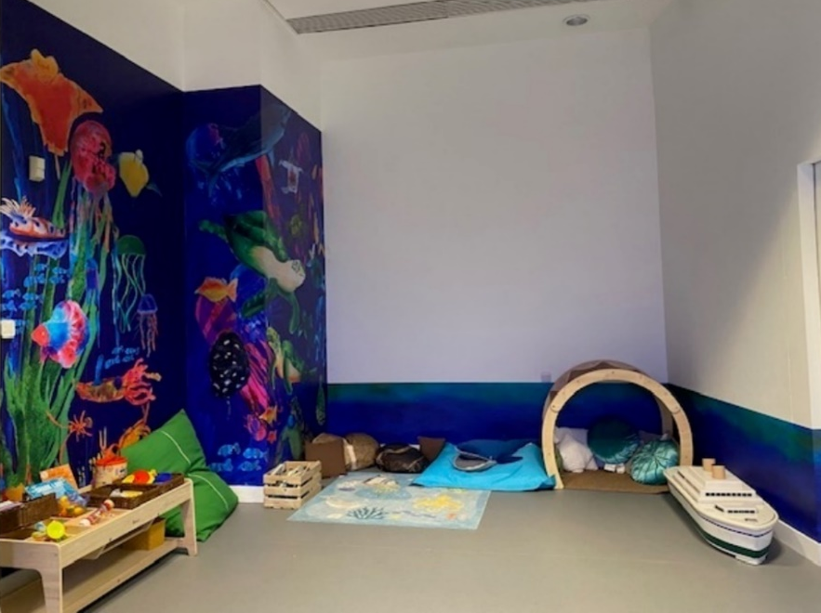
Ship Simulator, on Level 2. 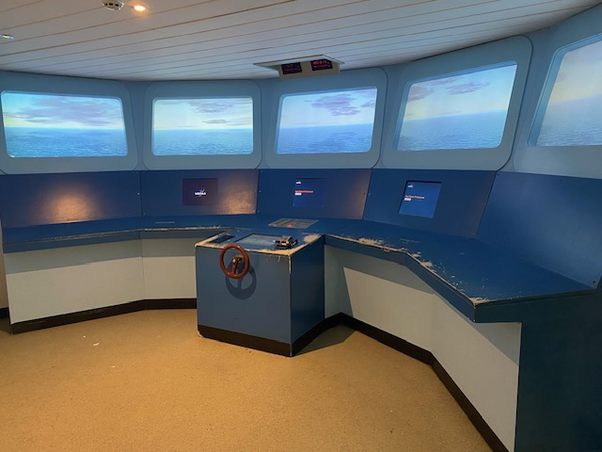

You can buy food and eat it in:
Parkside Cafe on Level 0.
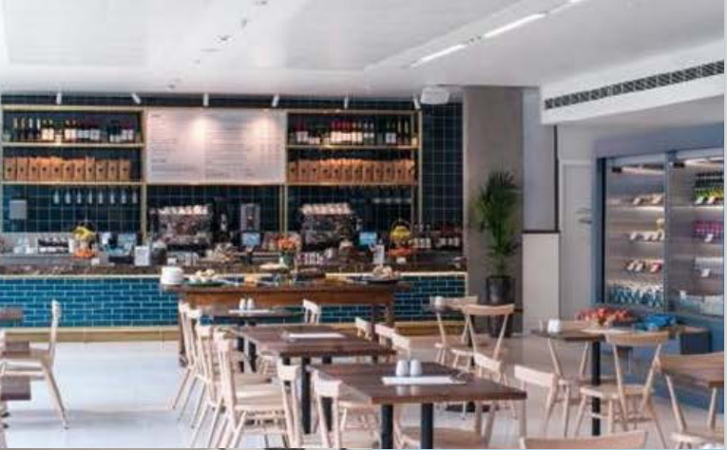

Ocean Court Cafe on Level 1. 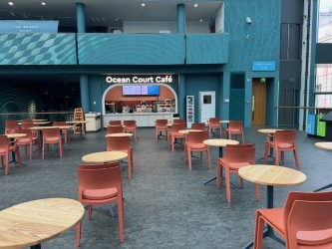

Shake Bar on Level 1.
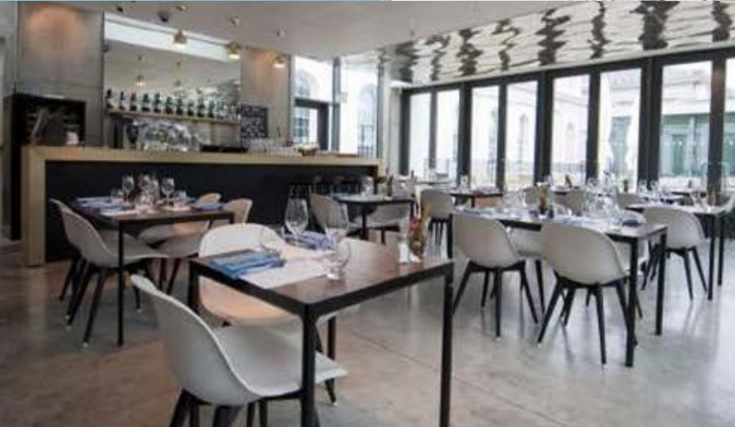
You could also eat in Greenwich Park. 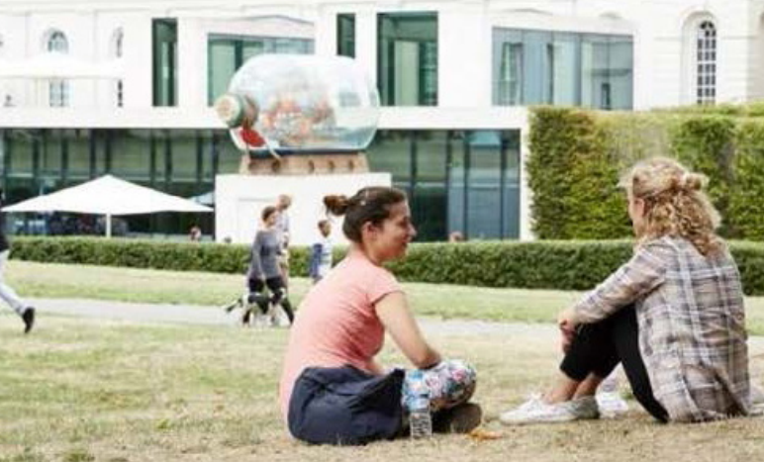
Sometimes, we have picnic spaces available within the museum. Ask staff if you’d like to use an indoor picnic space.
On Level -1, you can visit the Special Exhibition Gallery. Sometimes, the exhibitions in this gallery are charged.
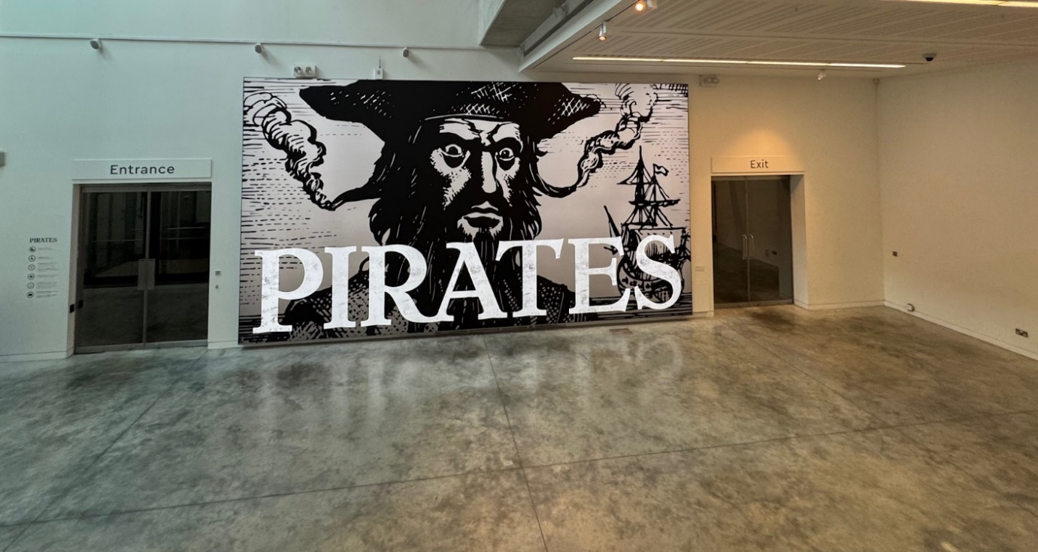

On Level 0, you can visit:
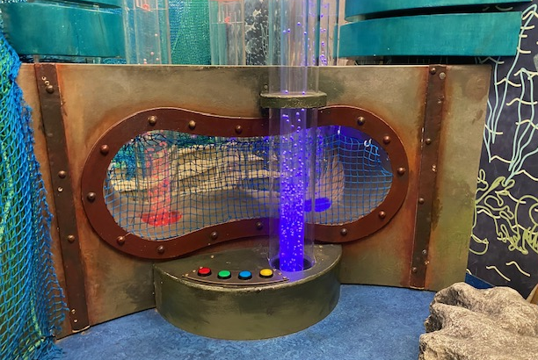
Ahoy!, The Windrush Museum, Maritime London, Voyagers, and Astronomy Photographer of the Year. 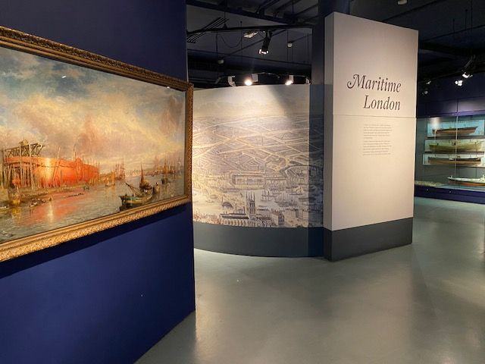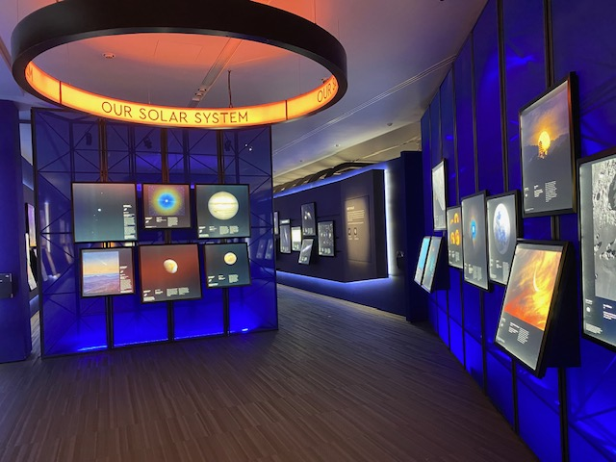 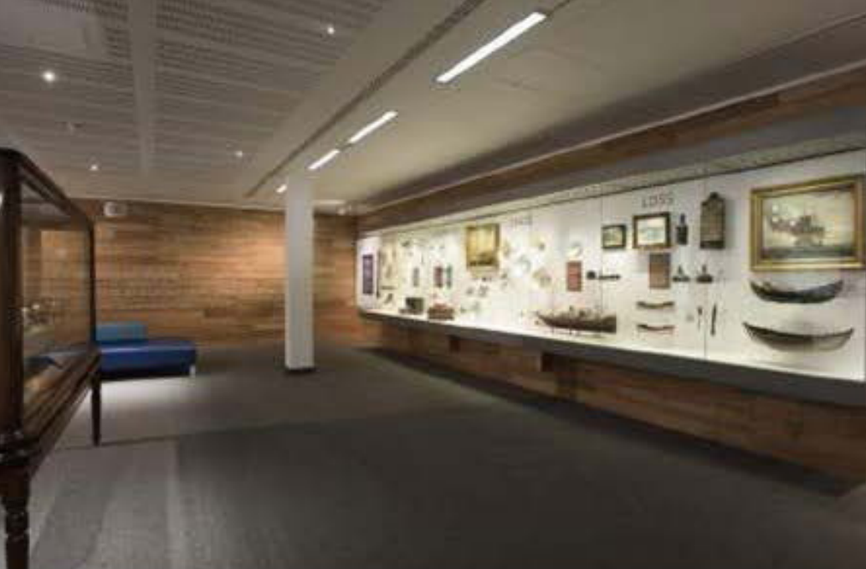
Pictures from top clockwise: Maritime London, Astronomy Photography of the Year, Voyagers, Ahoy!
Astronomy Photographer of the Year is a charged exhibition.
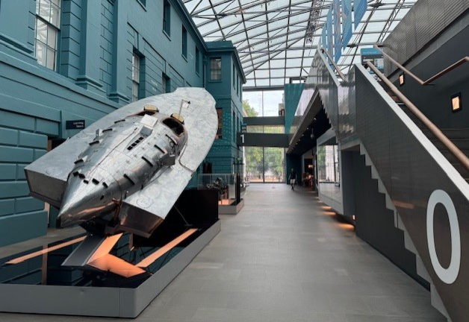
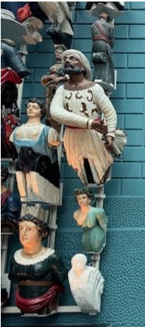
You can also see Prince Frederick’s Barge, Figureheads and Miss Britain III speedboat.
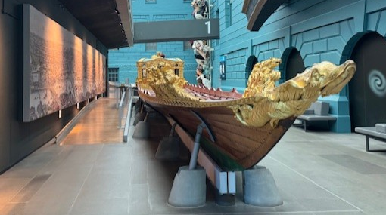

From top clockwise: Prince Frederick’s Barge, Figureheads and Miss Britian III
There are 3 sets of stairs and 3 lifts you could use to reach Level 1. The quietest set of stairs are the stairs by Voyagers gallery.
On Level 1, you can visit Atlantic Worlds, Traders, Poles Apart, Ocean Map, Sea Things, The Baltic Exchange Memorial Glass and Pacific Encounters. 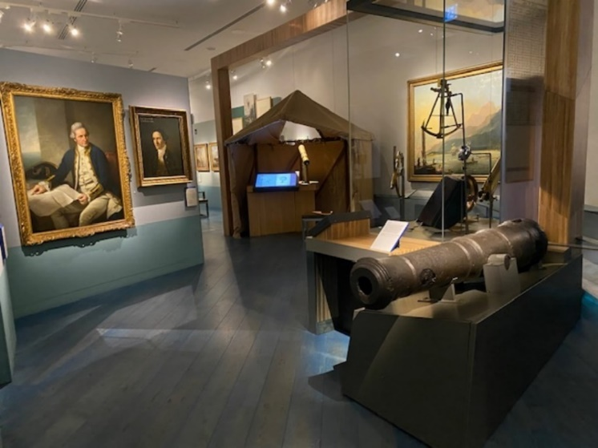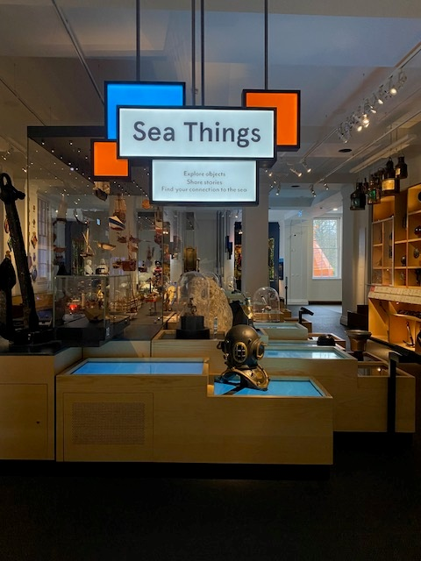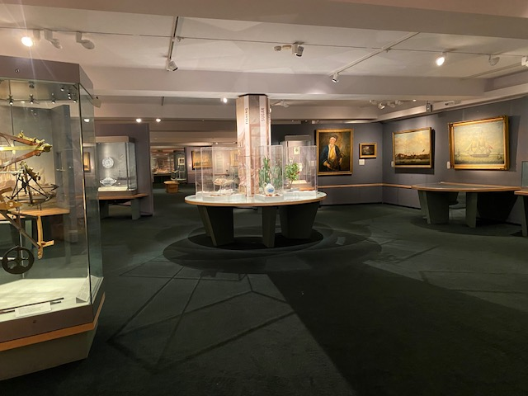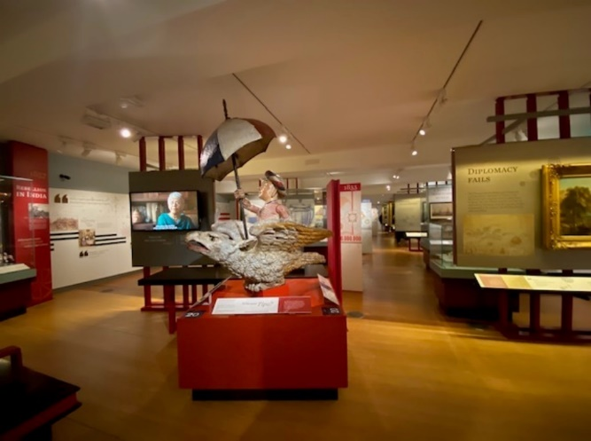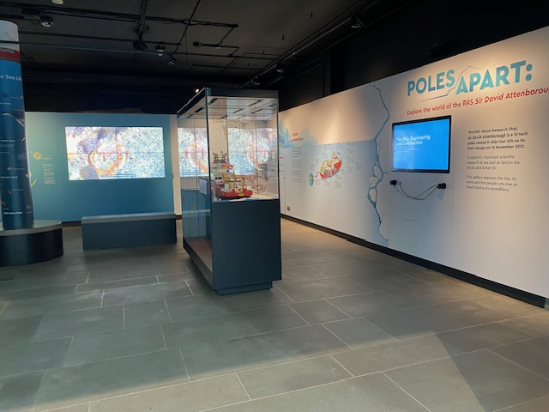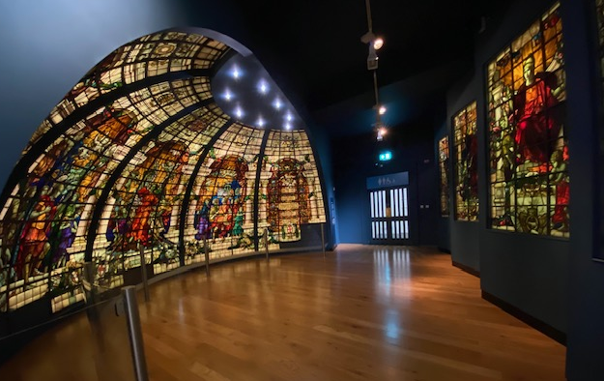
From top clockwise: Pacific Encounters, Sea Things, Atlantic Worlds, Traders, Poles Apart, Baltic Exchange Memorial Glass.
There are stairs and a lift next to Sea Things and Atlantic Worlds / Traders and by Ocean Map.
On Level 2, you can visit Nelson Navy Nation, Forgotten Fighters, All Hands Children’s Gallery, Small Hands, The Ship Simulator, Multi-Faith Room, Polar Worlds, My Greenwich and Tudor & Stuart Seafarers galleries. 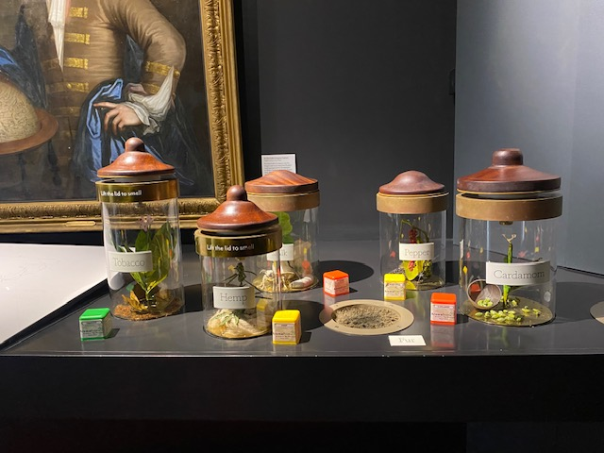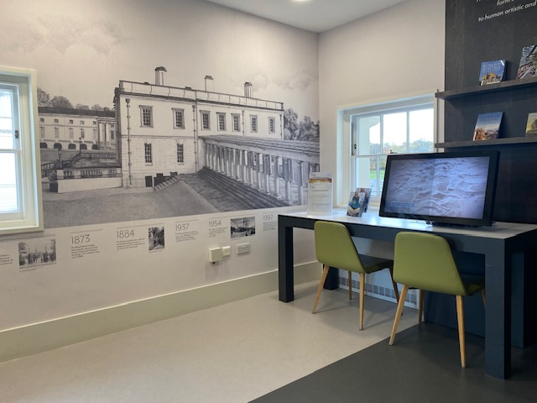
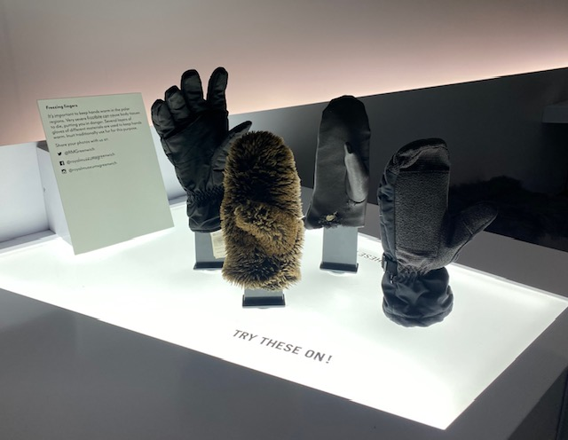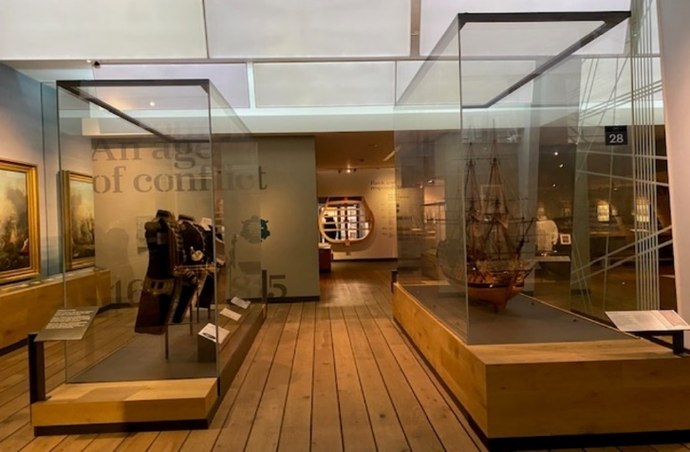
From top clockwise, Tudors & Staurts Seafarers, My Greenwich, Polar Worlds and Nelson, Navy Nation.
Lifts and stairs are next to Nelson Navy Nation / Forgotten Fighters, Tudor & Stuart Seafarers and Polar Worlds / Ship Simulator.
If you want somewhere quiet you can go to Voyagers or My Greenwich. If you want somewhere quieter, speak to staff and they will direct you to quieter rooms if any are available.
There is seating throughout the museum, as well as portable seats you can use. Some galleries have large print guides, and there are magnifying glasses and ear defenders available from the information desks.
For any assistance on site please speak to one of our friendly staff members. They will be dressed in a blue uniform and wearing a lanyard.
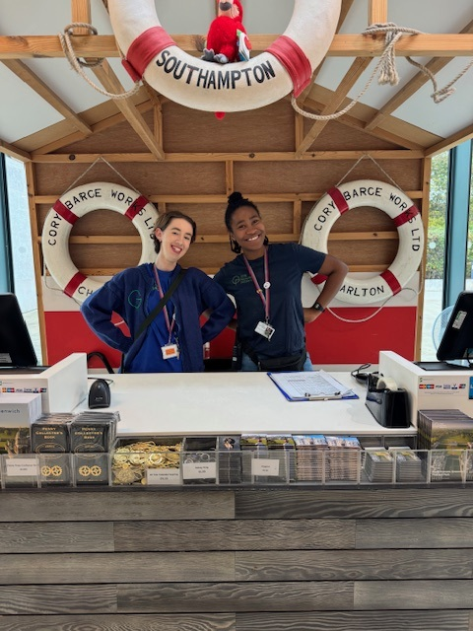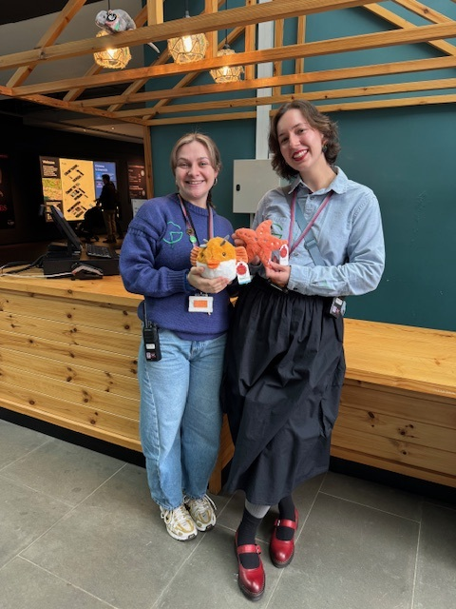
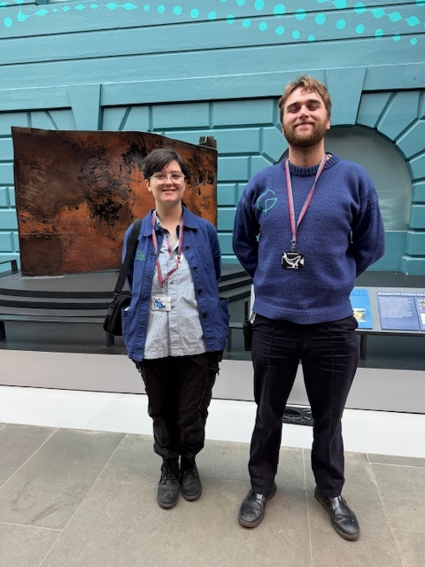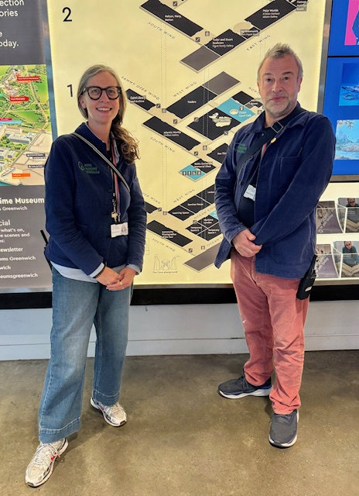
Our enquiries and booking office is open Monday – Sunday 9:00-17:00. Telephone 0208 312 6608
Email bookings@rmg.co.uk Enquiries@rmg.co.uk

