GCSE marketing

You can find evidence and information for your answers by exploring the National Maritime Museum website as a whole and the Leisure, travel and tourism section in particular.
Cut and paste or type your answers directly into these pages and save or print them for your portfolio.

- Look at the table below:
a) Identify the three remaining Ps in the marketing mix.
Product

P……….…

P……….…

P……….…

b) Describe how each factor of the marketing mix is used at the National Maritime Museum (NMM) in the table above.

Start looking in…
- Marketing mix in the Leisure, travel and tourism resource chest
GCSE marketing
- a) Find out as much information as you can about the Skin Deep exhibition or another special exhibition of your choice, which may perhaps appeal to the age group 14–19.
b) Give a brief description of the special exhibition/event.

Start looking in…
- Past exhibitions in What’s on. The Skin Deep exhibition is a good example
GCSE marketing
- Identify two suitable markets for the new exhibition.
1.
2.

Start looking in…
- Visitor research in the Leisure, travel and tourism resource chest

- Give two marketing research methods the NMM could use to identify the needs of all visitors.

1.
2.

From the information provided, give one reason why you chose each of the marketing research methods.

1.
2.

Start looking in…
- Visitor research in the Leisure, travel and tourism resource chest
GCSE marketing
- Identify what you think might be the best way of promoting the NMM to the types of visitors given in the table below. Give one reason for your choice. Complete the following table – one has been done for you.
Visitor type | Promotion | Reason
School groups | Direct mail to school event organisers or named teachers | Teachers organise school trips for their classes or subject groups
Visitors to London
Local families
Business/corporate
customers

Start looking in…
- Marketing strategy in the Leisure, travel and tourism marketing module
- Browse the Leisure, travel and tourism marketing module
GCSE marketing

- The NMM want to produce a leaflet for the Skin Deep: the history of tattooing or another special exhibition. In the box below give all the information that would be required for the leaflets. Suggest a possible layout for the leaflet.

Start looking in…
- Past exhibitions in What’s on.
- Leaflets and poster and flyers in the Leisure, travel and tourism resource chest
GCSE marketing
- Here is a selection of photographs/images from our website which could be used for promoting the Museum and its exhibitions.
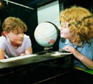  A Museum education session  from the Schools programmes KS 1&2 page | 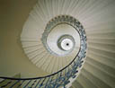  Queen’s House stairway  as used in the Film location services page |  | 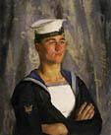  An ordinary telegraphist  from the ’Images of Seapower’ exhibition
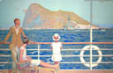  Poster of Gibraltar  from the ’Passengers’ gallery | 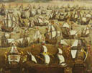  English ships and the Spanish Armada  from the Spanish Armada fact file |  | 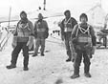  Photograph of Captain Scott’s Antarctic expedition  from the Scott fact file
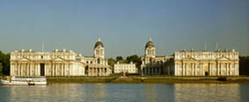  The Royal Naval College and the Queen’s House seen from the Thames  as used on Maritime Greenwich – World Heritage Site page |  | 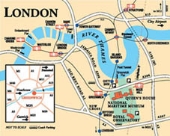  Travel map of central London  from our Visitor essentials page
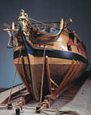  Model of the Royal George  from the ’Ship of War’ gallery | 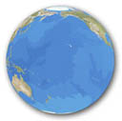  Planet Ocean image  from the ’Making Waves’ exhibition |  | 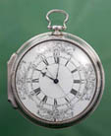  John Harrison’s H4 marine chronometer  from the ’Harrison’ exhibition
More images are available throughout the National Maritime Museum website
GCSE marketing
a) Which photograph would be best used for a press release and which for an advert?
b) Give reasons for your answers.

Start looking in…
- Marketing strategy in the Leisure, travel and tourism marketing module
- Browse the Leisure, travel and tourism resource chest
- Browse the National Maritime Museum website

GCSE marketing
- The NMM is planning a general marketing campaign to promote the Museum. It may also feature a special exhibition as part of this campaign. Give three objectives of the promotional campaign.
1.
2.
3.

Start looking in…
- Marketing objectives in the Leisure, travel and tourism marketing module
- Browse the Leisure, travel and tourism resource chest
- Browse the National Maritime Museum website. Past exhibitions is a good place to start
GCSE marketing
- Suggest three ways in which the NMM could evaluate the success of its promotional campaign.
1.
2.
3.

Start looking in…
- Visitor research in the Leisure, travel and tourism resource chest
- Browse the Leisure, travel and tourism marketing module

