Activity 1 – Life and times of Francis Drake
Teachers’ notes

Summary
Children explore and question five historical sources while gaining familiarity with the Tudor world in which Francis Drake and other adventurers set sail.

The activity helps students locate Drake in his historical context.

Time: 1 lesson

Supporting resources

Life and times of Francis Drake (PowerPoint)* – image and object stimulus to help students explore the character of Francis Drake and exploration in Tudor times

*Many of the paintings and objects can also be accessed from the online collections gallery

Suggested approach
Print out colour copies of each slide for children to examine in smaller groups.

Slide 1 – Introducing Francis Drake
Use the painting provided in the Life and times of Francis Drake powerpoint to generate curiosity and intrigue around the character of Francis Drake.

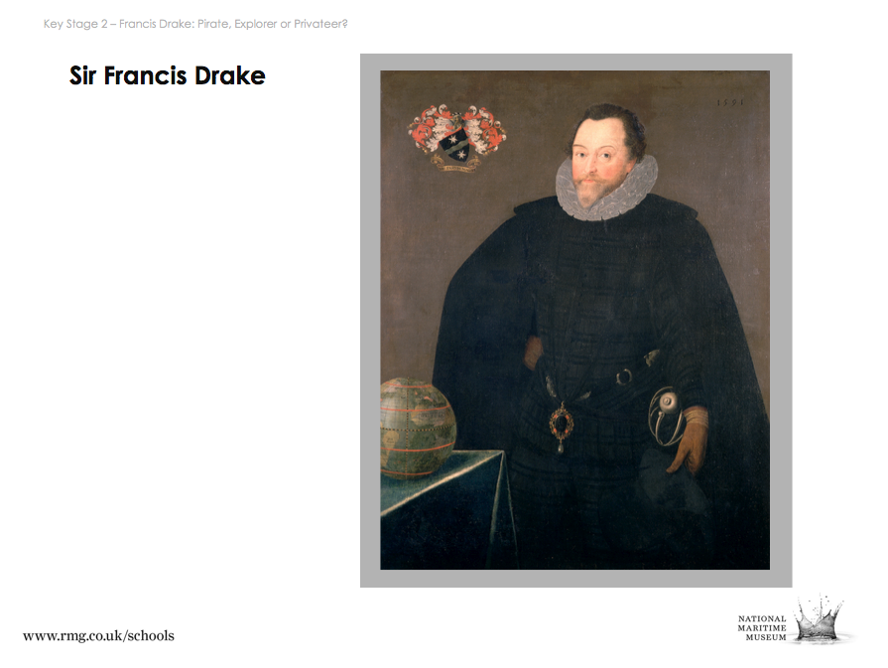

Tip: Suggested enquiry questions, background information on the painting and historical context is available in the PowerPoint notes for each slide

- Guide children in questioning the source.

- At any point you can reveal Drake’s identity:

“This man’s name is Francis Drake, and he’s famous because he was the first Englishman to circumnavigate the globe.

But no one can say for certain why he did it. We’re going to try to find out who this man was, and what people thought of him.”

- Ask children to guess what his motives were given what they’ve already found out.

Slide 2 – Writer John Stow on Francis Drake
Use this source to raise further questions about Drake, his motives and some of the events that took place on his voyage.

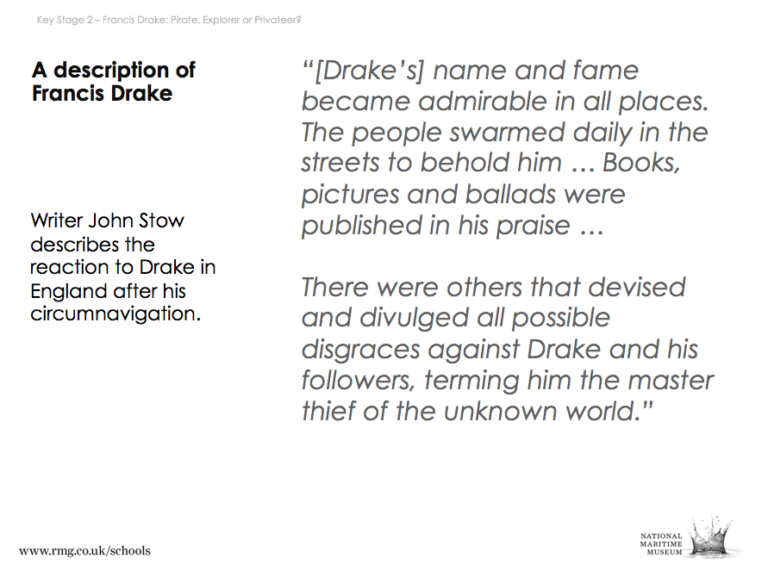

This quotation from a contemporary writer describes the reaction to Drake on his return to England after circumnavigating the globe.

- This source introduces the idea that people at the time had different perspectives on Francis Drake – eg, some characterized him as a ‘master thief of the unknown world’.

Slide 3 – World map by Abraham Ortelius, 1570
Use this map to help students begin to place Drake and Tudor exploration in their geographical and historical context.

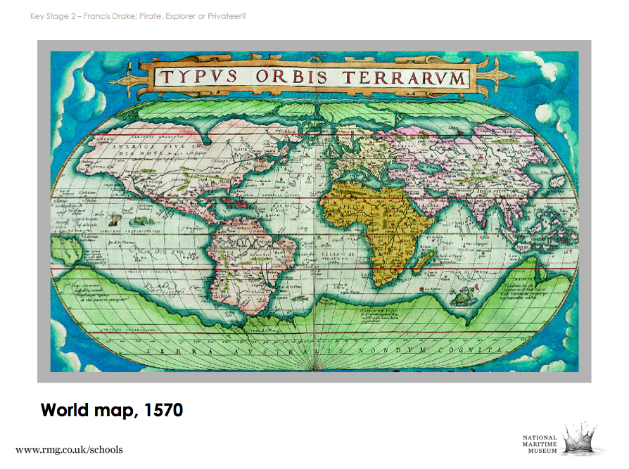

Tip: A description of the key differences and similarities with today’s maps is provided in the PowerPoint notes for this slide.

- Compare and contrast the map with today’s Google Maps.

- The map can also illustrate motives for exploration in the 16th century and the historical context. For example, Spain and Portugal dominated the wealth, trade and often the people in the known parts of America, Africa and Asia.

Slides 4 and 5 – Philip II, King of Spain, and Queen Elizabeth I
Use these paintings to illustrate England’s and other countries’ motives for exploration.

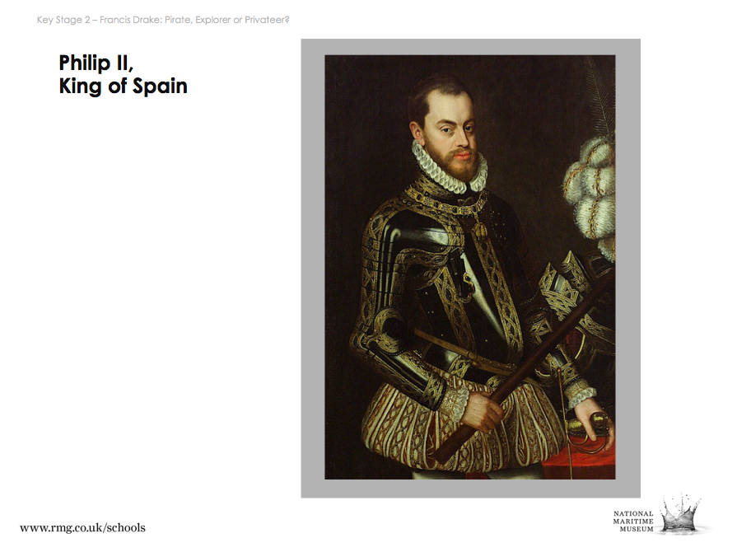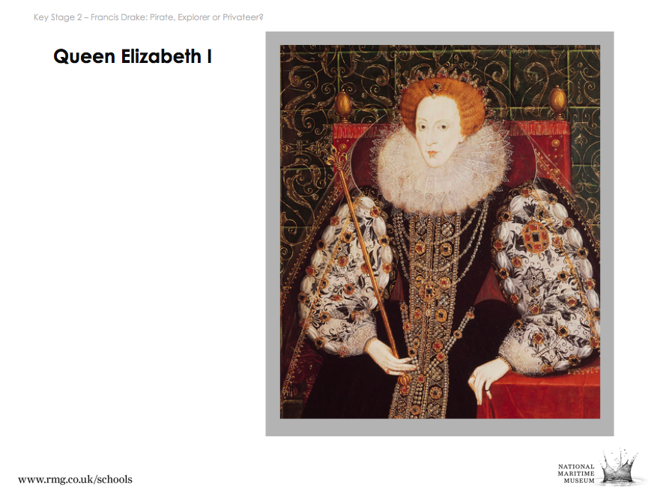

- Use the supporting PowerPoint notes to guide students in questioning the two paintings.

