Activity 2 – Examining historical sources
Background files

Question banks, source information and historical context for each of the objects or paintings used in Activity2: Examining historical sources.

This includes:

East India Company ships at Deptford, c1660

Chinese porcelain, c1780

The Money Brothers, 1788-92

Jamsetjee Bomanjee Wadia, c1830

Figurehead from HMS Seringapatum, 1819

More information on the history of the East India Company:

- HV Bowen, John McAleer and Robert J Blyth, Monsoon Traders: The Maritime World of the East India Company, 2011

- The East India Company, Portcities London website © NMM http://www.portcities.org.uk/london/server/show/ConNarrative.136/chapterId/2764/The-East-India-Company.html

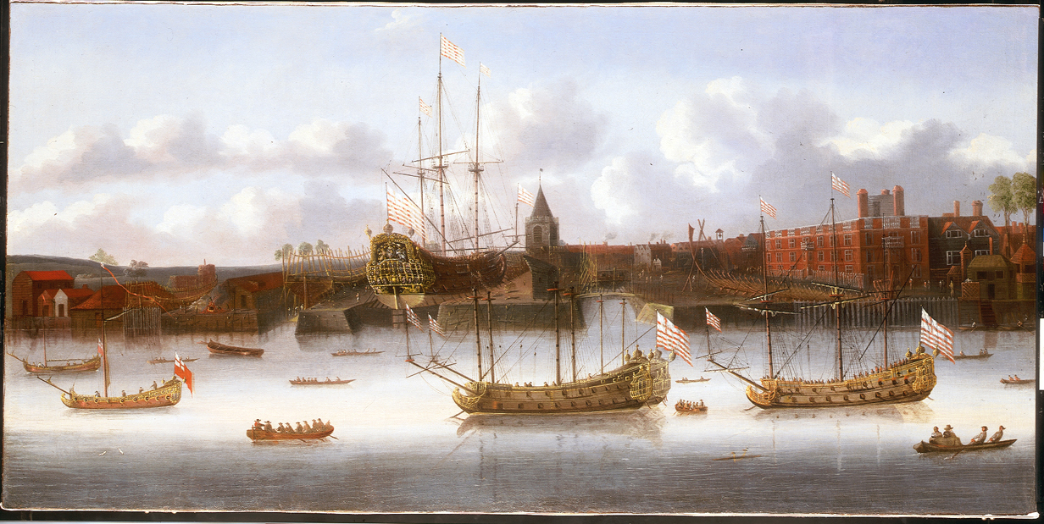
East India Company ships at Deptford

Source information

Title: East India Company ships at Deptford
Artist/maker: 17th century, English School
Date made: around 1660
Description: oil on canvas

Possible enquiry questions

- Why are these ships being built?
- Who do you think is building these ships?
- Why might these ships be armed?
- Do you think these ships are carrying anything? If so, what?

Examining the painting

This painting shows East India Company’s yard and buildings near Deptford Creek. Several ships are on the stocks. Their striped ensigns identify them as ‘East Indiamen’, the name given to ships built for the Company.
In 1660 the East India Company yard consisted of a dock and two slipways on the site at Deptford Creek, all clearly visible in this painting. On the river are several Indiamen at anchor as well as a range of various small craft.

Shipbuilding and the rise of the East India Company

Initially ships used by the Company were purchased privately. However losses from wear, tear and wreck took their toll and large ships suitable for the Eastern trade were soon at a premium.

In 1607 the Company decided to build its own ships and they leased a yard in Deptford. The ships built here were the ‘East Indiamen’ and for over 200 years they were the most superior vessel making the journey to the East Indies. They were built of wood, highly decorated and the interiors were finished to a high standard as much for the comfort of the passengers as for the cargo carrying capacity.

They needed to be fit for trade, but also war. Travelling to Asia was dangerous and so the ships were armed for engaging in conflict and defending trade. Pirates were a threat, as were European trading rivals such as the Dutch and Portuguese. The company’s ships were so well armed they were often mistaken for men-of-war.

At first the Company’s decision to build its own ships was justified, but the shipbuilding and maintenance of these yards at Deptford soon proved highly expensive to run.

Later in the 17th century, the Company reverted to the practice of hiring vessels, many of which were built in the private yards at Deptford and Blackwall.
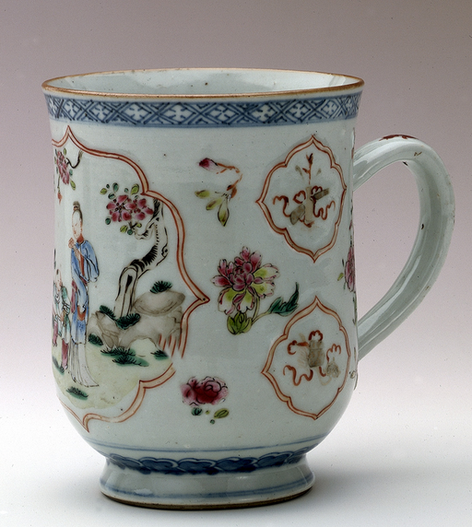
Chinese porcelain

Source information

Title: Mug
Artist/maker: unknown
Date made: around 1780
Place made: China
Description: porcelain

Possible enquiry questions

- Where do you think this mug might have been made?
- Who do you think it was made for?
- Why might this porcelain mug be shaped like a tankard?

Examining the object

This is a porcelain mug painted with a lady and a boy in a garden and peonies.

On the sides of the mug are a treasure vase symbolising perpetual harmony with scrolls behind, and also a writing case and sceptre.

It was made in China for export to Europe. The shape imitates that of an English silver tankard of about 1745.

It belonged to Mrs Elizabeth Cook, the wife of the famous explorer Captain James Cook.

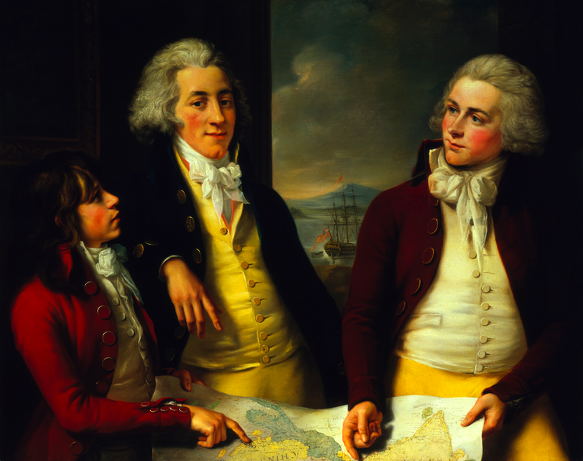
The Money Brothers

Source information

Title: The Money Brothers: William Taylor
(1769-1834), James (1772-1833) and Robert
(1775-1803)
Artist/maker: John Francis Rigeault
Date made: 1788-92
Description: oil on canvas

Possible enquiry questions

- Who are these three people? What do you think their story is?
- What do the objects and surroundings say about the people in the picture?
- Why do you think this picture was painted?
- Why has the artist included the ship out the window?

Examining the painting

This group portrait is of the three sons of William Money, a Director of the East India Company. It was commissioned by Money’s lifelong friend and business partner Sir Robert Wigram Bt.

The central figure, William Taylor, was a lieutenant of the East India Company marine service. His brother Robert is on the left wearing a red coat.

Robert is pointing to a map of Asia at the place marked Canton in China. James, on the right, holds the other end of the map and points to Calcutta.

Through a window the East Indiaman Rose is shown at anchor. This is the ship on which William Taylor had his first East India Commission as a lieutenant.

It took several years to complete this painting because the brothers could only sit for the artist when visiting Britain. The finished work was exhibited in the Royal Academy in London in 1792.

Private traders in East Asia

While the growth of the Company’s import trade to Britain was impressive, at no time did this represent the full extend of East India trade.

Private traders had always sought access to Asian markets. Most of these men were Company servants stationed in India, well positioned to provide shipping services to the country trade across the Indian Ocean.

There was also opportunity to supply other services such as insurance and financial services. Over time, such businesses evolved into powerful operations.

Other individuals operated what was known as the ‘privilege trade’ – the opportunity to undertake long-distance private trade between Britain and Asia.

This sometimes went along with smuggling considerable quantities of goods out of Indian ports and Canton destined for Britain.

It was well known that personal fortunes could be made by trading privately in East Asia. The command of an East Indiaman was a highly coveted maritime appointment that could cost up to £5000 to purchase.

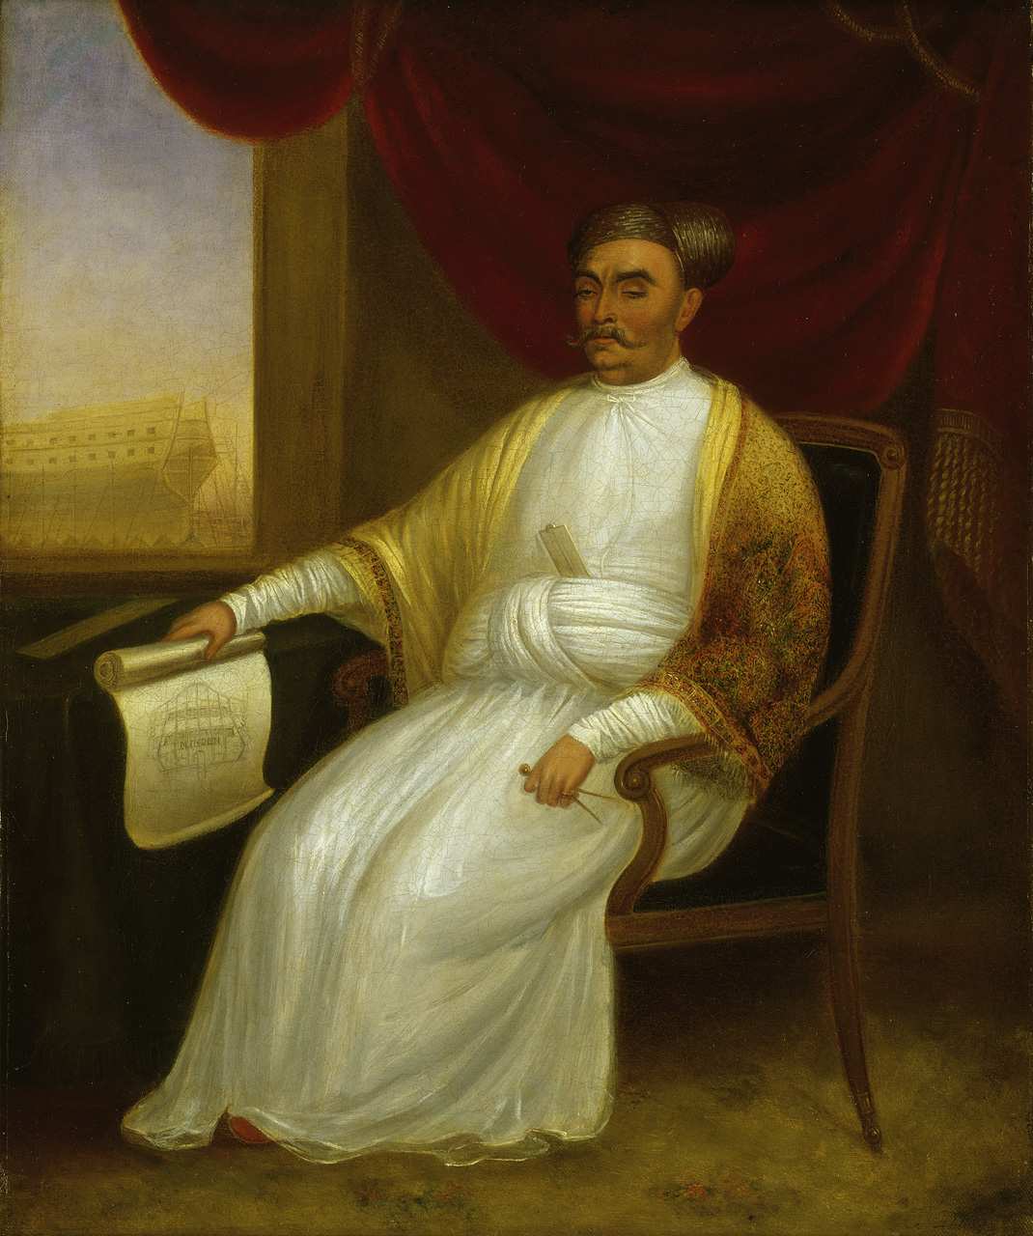
Jamsetjee Bomanjee Wadia

Source information

Title: Jamsetjee Bomanjee Wadia, 1756-1821
Artist/maker: attributed to J Dorman
Date made: around 1830
Description: oil on canvas

Possible enquiry questions

- Where is Jamsetjee? Describe the room and objects
- What can you see in the painting to help you find out Jamsetjee’s job?
- Why do you think this picture was painted?
- What might this painting tell you about the East India Company?

Examining the painting
The sitter – Jamsetjee Bomanjee Wadia – is holding a pair of dividers in his left hand and a drawing in his right. The draught is of the stern of the Minden, a 74-gun ship launched at Bombay in 1810. The Minden, half-built, is shown through the window – the first of a line of ships to be built for the Royal Navy outside of England.
He sits on an ornate western-style chair on a silk carpet. Behind him are the swags of heavy red curtain with gold tassels. He also wears a white robe and embroidered pashmina shawl. It was customary for shipbuilders to be given shawls by representatives of the East India Company at the launching of a new ship.
Wadia also has a silver ruler in the painting, a gift from the East India Company.
Who was Jamsetjee Bomanjee Wadia?

Jamsetjee Bomanjee Wadia was a highly skilled shipwright working in the Bombay Dockyard around the turn of the 19th century. His talents were recognised by the East India Company and the Royal Navy. His family were Parsi shipbuilders from Surat, highly respected in Bombay and by the East India Company directors in London.

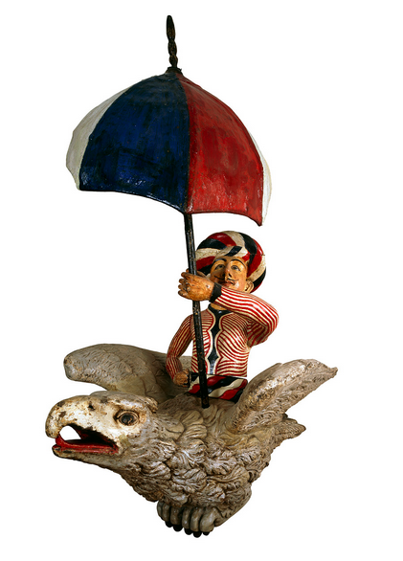
Figurehead from HMS Seringapatum

Source information

Title: HMS Seringapatum [Tipu Sultan?]
Artist/maker: unknown
Date made: 1819
Place made: Bombay, India
Description: copper; iron; lead paint; pine

Possible enquiry questions

- What kind of ship was this sculpture on?
- Who do you think the man on the bird might be?
- Why do you think the East India Company had an army?

Examining the object

This carved wooden sculpture is thought to be a figurehead of HMS 'Seringapatam', a 46-gun frigate built for the Royal Navy at the Bombay Dockyard in India in 1819.

The seated turbanned figure probably represents Tipu Sultan, ruler of Mysore. He is riding on a roc - a mythical bird of great strength – and holding an umbrella, both symbols of this character’s regal status.

Who was Tipu Sultan?

Tipu Sultan of Mysore ruled an extensive empire in southern India. He and his father before him resisted the advance of British power in India, and had a long and bloody antagonism to the extension of East India Company rule.

While some local Asian rulers cooperated and collaborated with the East India Company, some – like Tipu Sultan – stubbornly resisted the Company’s advance. They resented the presence of foreign powers.

